Why you should visit Cologne

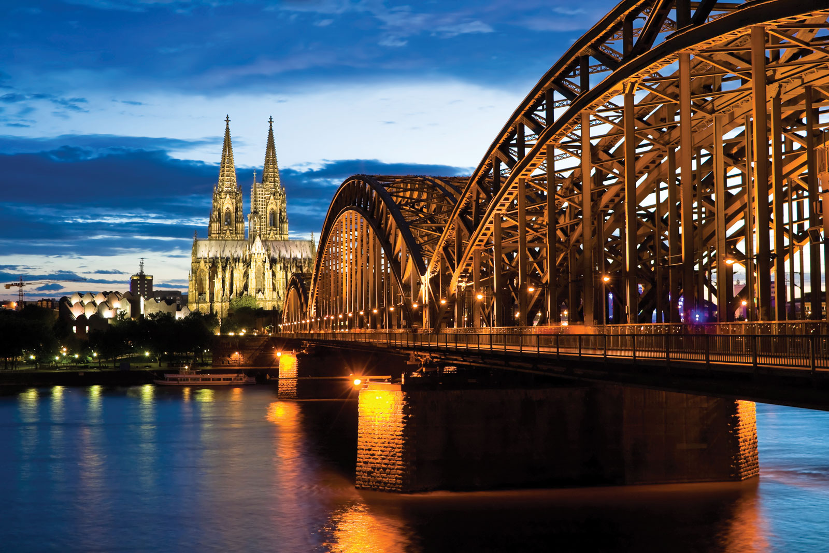
Cologne located in Germany has lots of nice things to look at like the city views and the River Rhine because it runs through Cologne and you could take a cruise on it which has lovely scenery, and you will see the famous Hohenzollen bridge. There is also a cable car attraction to see the scenery from higher up and seasonal christmas markets you may like to visit which are very popular.

Museums:
It has many museums to visit, for example an unusual one called Augustusburg is a Rococo-era castle which has motorbike museum inside with 175 exhibits. There is also a chocolate museum if you have more of a sweet tooth.

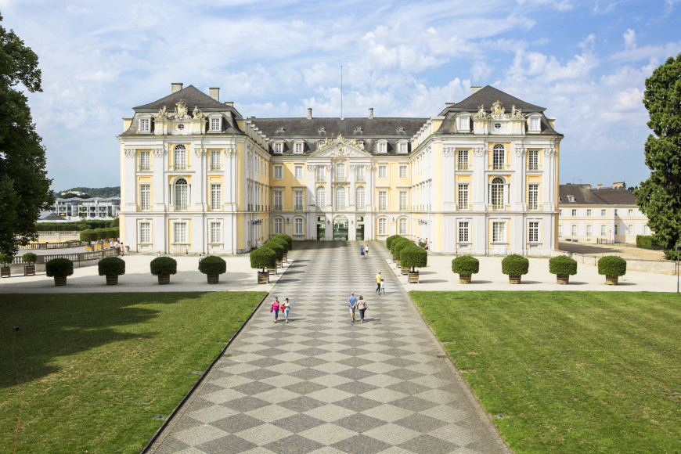

Zoological Gardens:
The Cologne zoo founded in 1860 is called Kolner Zoologischer Garten and is one of Germanys oldest zoological gardens. It has a collection of 19th-century Menagerie buildings that include elephant houses and an old bird house which is now a chimp enclosure that resembles a traditional Russian church. The other amazing features are; an ape island with a mock rainforest, an aquarium, cat enclosure, and a biotope habitat where visitors view through glass windows.



Botanical Gardens:
Established in the 19thcentury near the riverbank Riehl lives Flora and Botanical Garden that covers 11.5 hectares covered with more than 10,000 types of flowers, it’s a local park so you can stroll through the flowers or learn more about them.

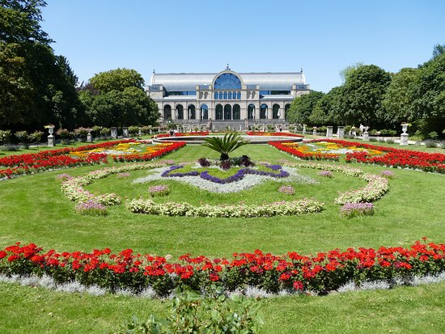

Cathedral:
Cologne Cathedral is a catholic church which is exactly 86.25m wide and144.5m tall and it’s very nice to look at. One of its most famous attractions is The Shrine of the Three Kings which is said to contain the bones of the three wise men from the bible.



