VISIT COLONGE
Are you looking for a short city break? Visit Cologne today to enjoy historical tourist attractions, peaceful beautiful scenery alongside the River Rhine and enjoy a taste sensation at one of the many restaurants.
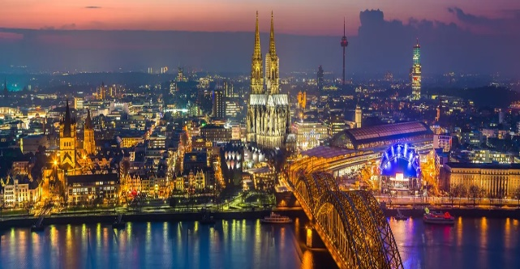

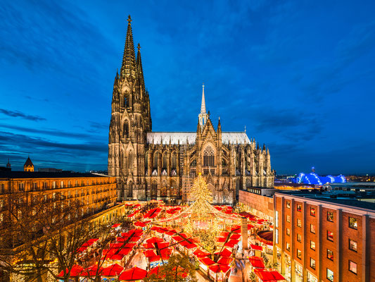

ABOUT US
Cologne is one of the oldest cities in Germany, with over 106,100,000 people living in Cologne. Cologne, a 2,000-year-old city spanning the River Rhine in western Germany. Cologne is famous for the Christmas markets that always bring people together to enjoy the fun and beautiful festivals.
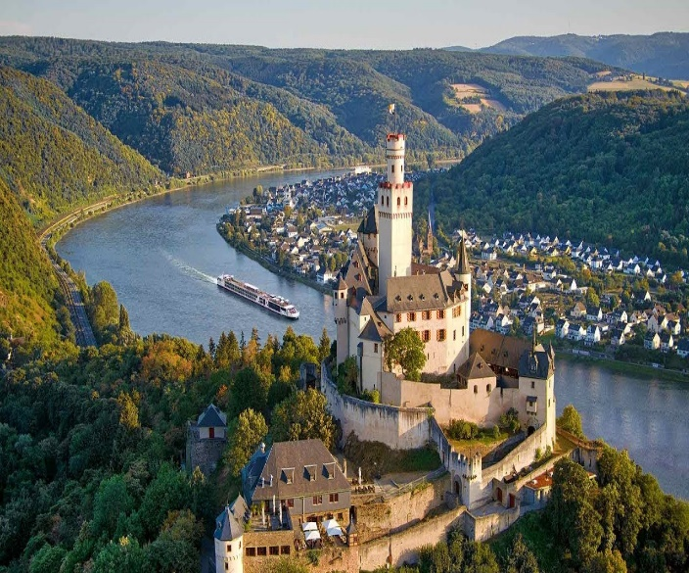

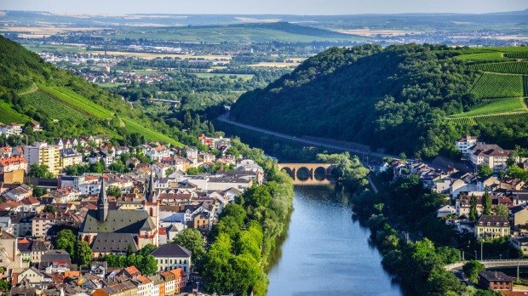

TOURIST ATTRACTIONS
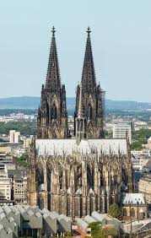
Come and enjoy one of many historic attractions like the Cathedral, that was built from 1248. It was declared a world heritage site in 1996.

For the historians why not visit one of our 31 museums.
We have something for everyone.
Do you have a sweet tooth? Then the Cologne Chocolate Museum is a winner. This sweet-smelling museum shows the history of chocolate. Are your taste buds tangling?
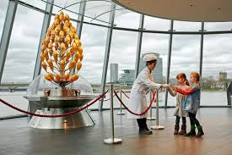


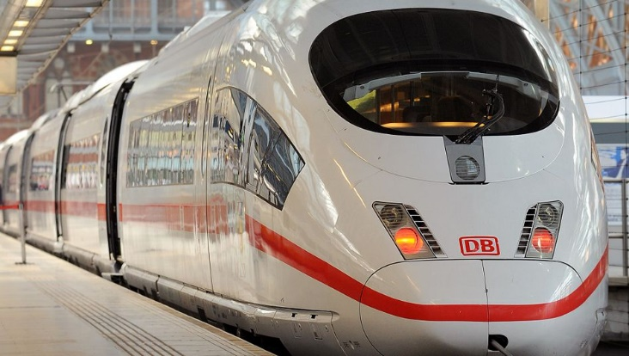
GETTING AROUND

If your legs are floppy, why not go on a scenic and tranquil boat trip down the River Rhine that will treat your eyes to different views of this beautiful city. The easiest and quickest way to get around is by going on a high-speed train-giving you a stress-free holiday.

Visit Cologne today and enjoy everything this vibrant city has to offer.
For more information:
- Visit www.visitcologne.com
- Telephone
+987 646 981
Book your trip before 31 March 2021 to receive 10% of your holiday booking.
So, what are you waiting for? We look forward to welcoming you.

