Four reasons to visit Cologne
Cologne is the 4th largest city in Germany, with the River Rhine running through it. You will find Cologne in the north east area of Germany, just like the map tells you below. 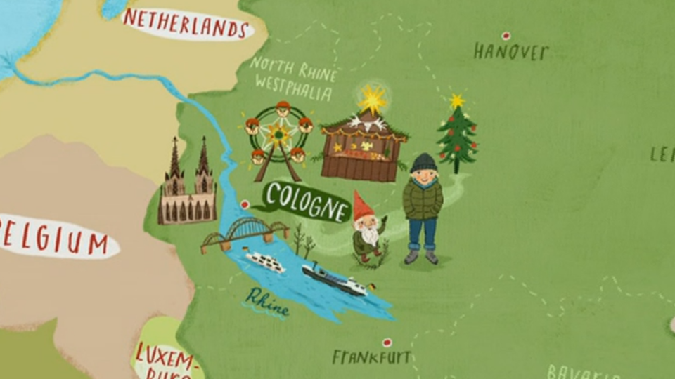

The River Rhine
The River Rhine flows through the middle of Cologne making the city have beautiful high places to see the city, the River Rhine, boats and even castles! Did you know that the River Rhine is over 1000 kilometres? The source of the river is high up in the Alps in Switzerland and the mouth is in Rotterdam in the Netherlands.

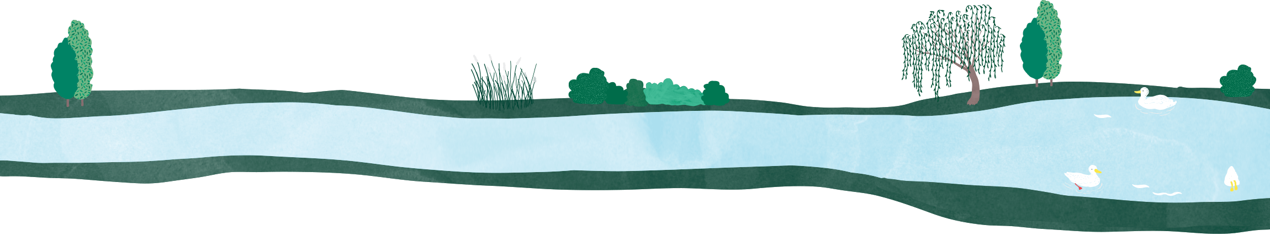

The Trains
You can get around Cologne on a bus or a tram but the highspeed trains are most fun. One speedy train is called ICE which stands for Into City Express. ICE can go up to 300 kilometres per hour, that’s fast! Its even the fastest train in Germany. Another train is called the Double Express where you can sit upstairs and downstairs.

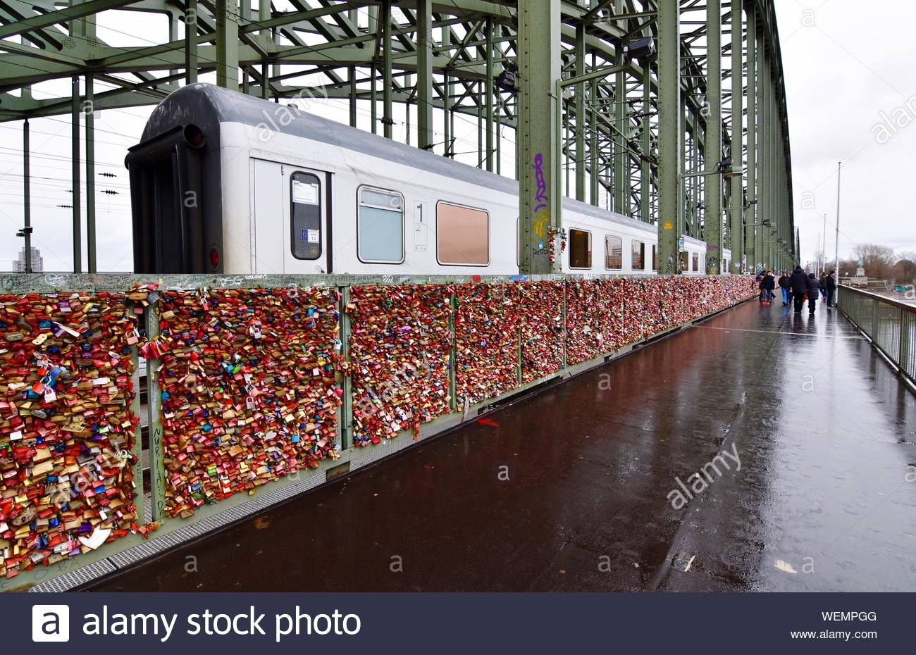
If you travel on a train you might be able to cross the famous Hohenzollern bridge, the bridge has over 40,000 love padlocks on it. People put on padlocks to show how much they love each other, once they’ve locked the padlock, they throw the key in the River Rhine to show that their love will never be broken.

The Cathedral
The old Cathedral is a very popular tourist landmark, it is one of the most visited sites in Germany. It took around 750 years to be built. Cologne Cathedral has the largest
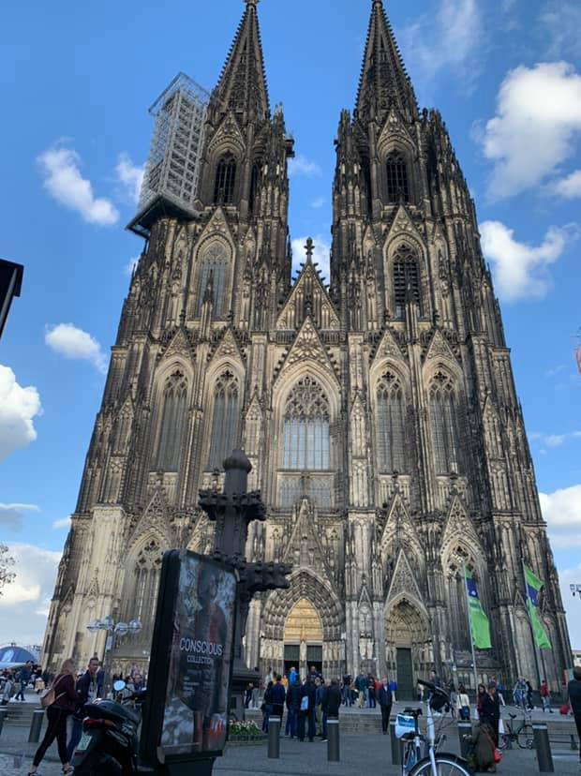
free swinging bell. It is called Fat Peter and weighs 24 tonnes.

Christmas Markets


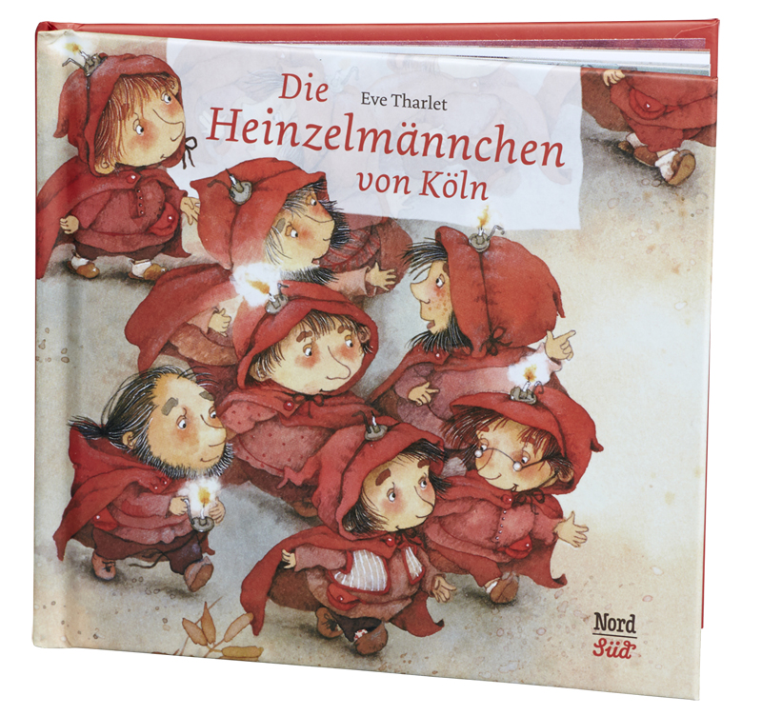
The last reason to visit Cologne [ my personal favorite] is the Christmas Markets. The market in the old part of Cologne is called The Elves Market, it’s called that because of the city’s very famous fairy tale called the Elves of Cologne. There are over 4 million tourists visiting the markets in 4 weeks, especially in December.
There is also a part of the markets where you can see a wood sculptor sculpturing wood and learn lots about the wood cutting. If you come on a mini off-road samba train, you’ll be able to have lots of fun. Finally, there are lots of food markets with delicious goodies and treats to enjoy.

Conclusion
Now that you’ve learnt about Cologne what do you think? Is it a city you’re now planning to go to in the holidays? or is it not good enough for you? I definitely know where I’m going for the holidays. If you want to you can research on more about Cologne until then it’s goodbye from me Evan Tyson.

