The Golden Key
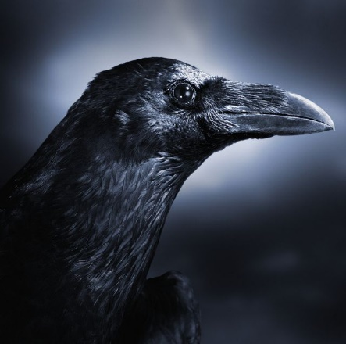
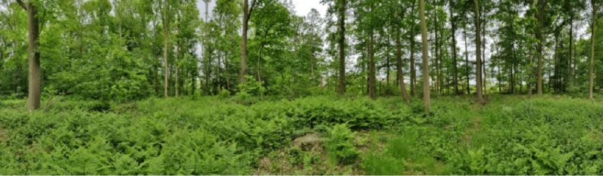
The crow is going to quickly doge the girl so she doesn’t get the key but the girl wasn’t going to give up so the girl chased after it. But then there was a huge gap in the forest so there was no hope of getting the key but there was a log that went from one side. The crow was sitting on a branch on the other side. She was about half way across but then the crow dropped the crow. The girl was frightened that she wasn’t going to get it so she quickly jumped from the log diagonally across and snatched the key. She just managed to get to the other side without falling in the gap.

