Please type your name here Remember to save your work and ask a parent to send via email or ask an adult to take a photograph and send to me via email.
You can type your answers, left click where you would like to type, and the cursor should flash. You can now type
or ask an adult to print and write the answers.
Lesson 3 – Activity 1
05.01.21
To calculate perimeter of 2D shapes in cm
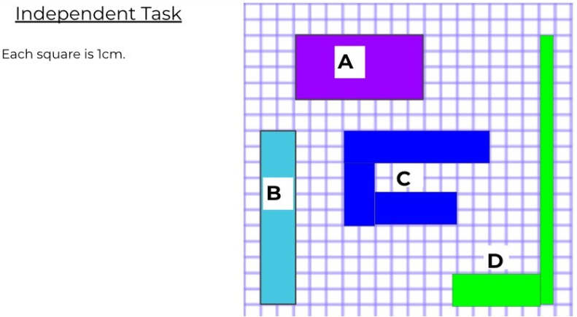
The perimeter of shape A is cm.

The perimeter of shape B is cm.

The perimeter of shape C is cm.

The perimeter of shape D is cm.

Please type your name here Remember to save your work and ask a parent to send via email or ask an adult to take a photograph and send to me via email.
You can type your answers, left click where you would like to type, and the cursor should flash. You can now type
or ask an adult to print and write the answers.
Lesson 4 – Activity 1
05.01.21
To calculate perimeters of 2D shapes in mixed units

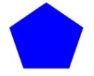Each side of this pentagon has a length of 7cm and 1mm. What is the perimeter of the pentagon?
The perimeter of the pentagon is
cm and mm

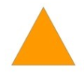One side of this equilateral triangle is 5cm and 3mm. What is the perimeter of the equilateral triangle?
cm and mm

Each side of the hexagon has a length of 2cm and 1mm. What is the perimeter of the hexagon?
cm and mm

