Please type your name here Remember to save your work and ask a parent to send via email or ask an adult to take a photograph and send via email.
You can type your answers, left click where you would like to type, and the cursor should flash. You can now type
or ask an adult to print and write the answers
or copy the table onto a piece of paper, then complete the activity.
Lesson 1 - Activity 1
04.01.21
Measuring lengths to the nearest cm or mm (independent task)
Cut 5 strips of papers of different lengths and measure them to the nearest cm and mm
Strip | Measurement to the nearest mm | Measurement to the nearest cm
1
2
3
4
5

Please write your name here Please print this worksheet and ask an adult to take a photograph and send your work to me via email

Lesson 1 - Activity 2 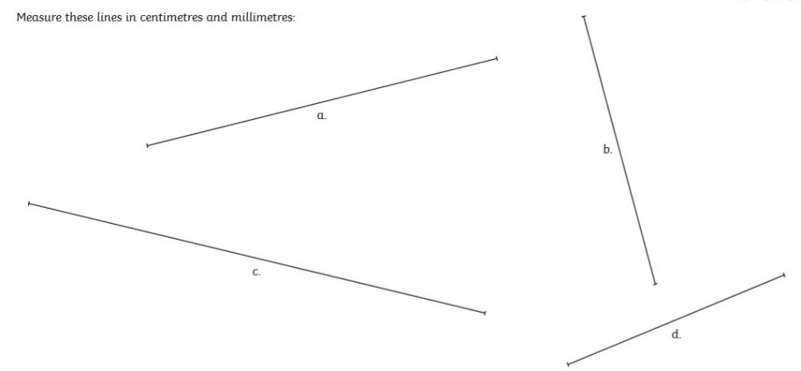

Please write your name here Please print this sheet and ask an adult to take a photograph and send to me via email
Lesson 2 - Activity 1
04.01.21
Measuring length and drawing lines of a given length in mixed units



