Please type your name here Remember to save your work and ask a parent to send via email or ask an adult to take a photograph and send via email.
You can type your answers, left click where you would like to type, and the cursor should flash. You can now type
or ask an adult to print and write the answers.

Lesson 7 – Activity 1
07.01.21
Length and perimeter application lesson

One side of a square measures 6cm.
What is the perimeter of the square?
The perimeter of the square is

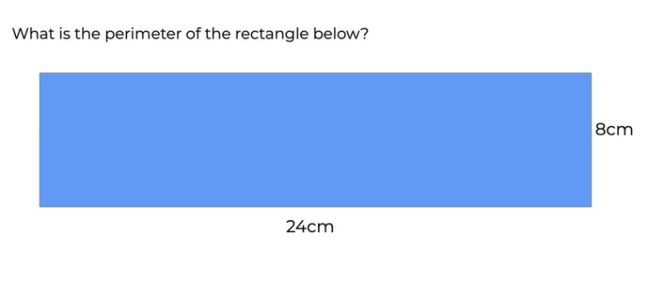

The perimeter of the rectangle is

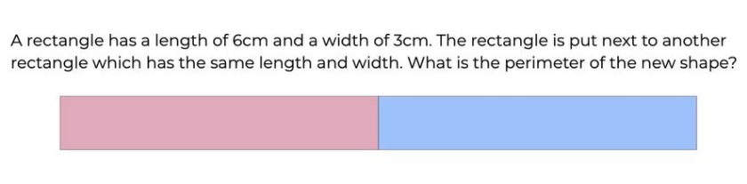
The perimeter of the new shape is

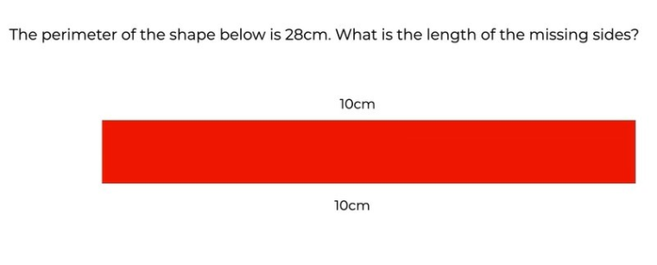

The length of the missing sides is

Please write your name here Please print these worksheets and ask an adult to take a photograph and send to me via email
Lesson 8 – Activities
07.01.21
Draw Shapes of a given perimeter



