
Personal Challenge Competition

This year PASS will be running a personal challenge each term. Children do the challenge at school record the results on the spreadsheet provided and send the result to demi@passltd.org. The results will be analysed, and certificates awarded across the year groups and key stages in your school and other schools.

Term 4 Challenge – The Rebound

This is a test of rhythm, balance, and coordination in a set time.

The challenge will be differentiated between Key stages by a varied amount of time to perform the challenge in.
- EYFS – 20 seconds
- Key stage 1 – 30 seconds
- Key stage 2 – 45 seconds.

The Rebound – Using a tennis racket and beanbag or small ball depending on year group (if at home children can use a book and rolled up socks or rolled up piece of paper) children will attempt to bounce the ball up and down on the racket as many times as they can within their time limit. If the ball falls, they can pick it up and continue counting from when the ball fell.

EYFS and KS1 – Children may use a beanbag for this challenge -If at home children can use a book and rolled up socks/paper – they may need to be encouraged to look at the beanbag and to try small movements of their racket.

KS2 – Children will use a tennis ball for this challenge - If at home children can use a book and rolled up socks/paper. Encourage them to have a loose wrist action to continue the rebound bounces, focus on the movement of the ball and try to keep the racket movements small to keep the ball under control.
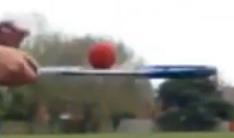
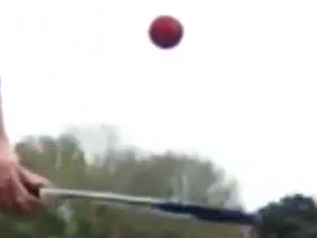

Count how many rebounds are performed in the time limit.

Rules:
- Starting on the whistle the participant must complete as many Rebound bounces as possible in the time limit.
- Each time the ball lands back on the racket counts as 1 point.
- If the ball falls to the floor children can replace the ball on the racket and continue counting from the number it fell.
- The time stops on the whistle.

Tips:
- Two judges are recommended one for timing and one for counting. If not enough stop watches then class teacher can time for everyone at once.
- Keep the counter consistent so this remains a fair test.
- Ensure participants in a good space to avoid being hit by any balls.
- During the session try not to have everyone waiting around for their turn.
- Encourage children to practice on their own to attempt to improve their score.
- Repeat the personal challenge at the end of term and record the results to see if there has been an increase in their score.

