Week 1 spellings Oak Class 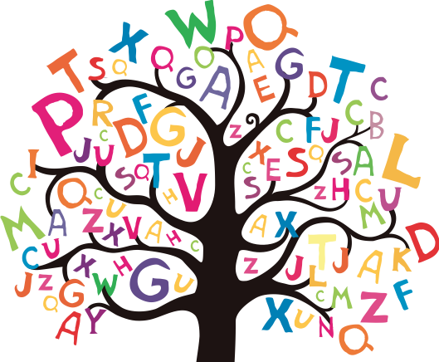

misread
mistake
mistreat
misspell
misprint
mislead
mismatch
misplace
misbehave
misunderstand

