Week 2 spellings Oak Class 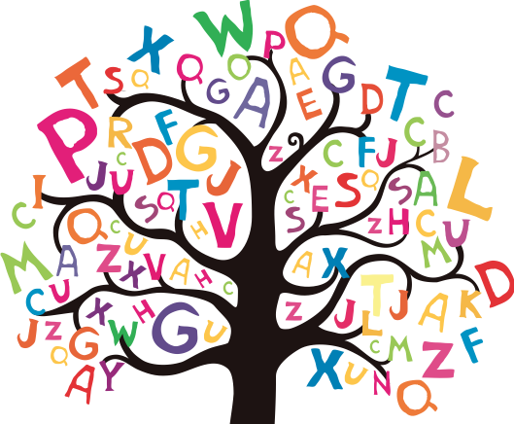

measure
treasure
pressure
leisure
pleasure
enclosure
measurement
leisurely
measuring
treasured

