Week 3 spellings Oak Class 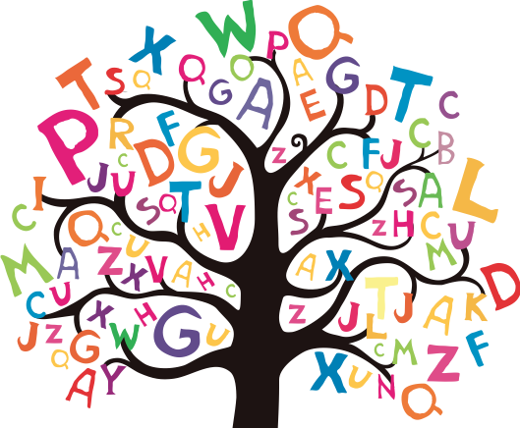
Words in italics are revision words from last few weeks.
automatic
automobile
autograph
autopilot
autobiography
autocue
leisure
creature
mistreat
misbehave

