Week 4 spellings Oak Class 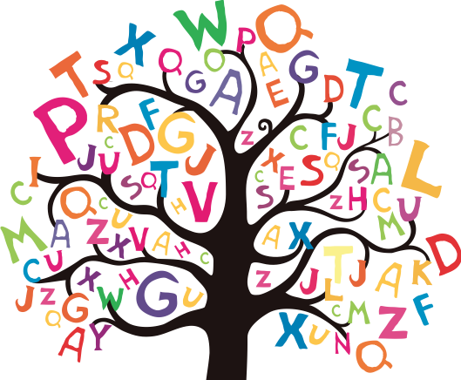

breezily
sleepily
cosily
cheekily
happily
luckily
angrily
heavily
noisily
lazily

