Week 5 spellings Oak Class 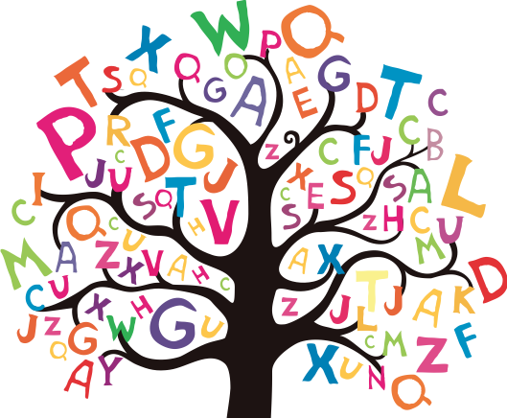

interact
intercity
intergalactic
international
interrelated
internet
interview
remember
regular
recent

