Week 5 spellings Oak Class 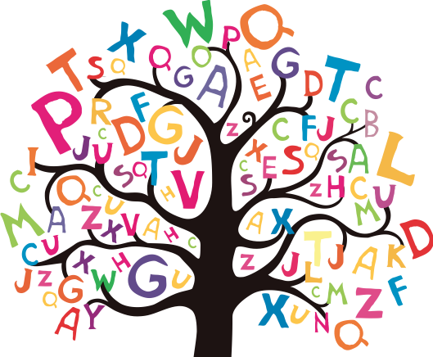

interact
internet
interview
remember
recent

