Week 6 spellings Oak Class 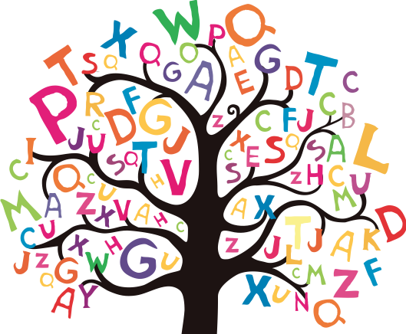

eight
weigh
sleigh
neighbour
vein
veil
rein
reign
obey
prey

