Week 6 spellings Oak Class 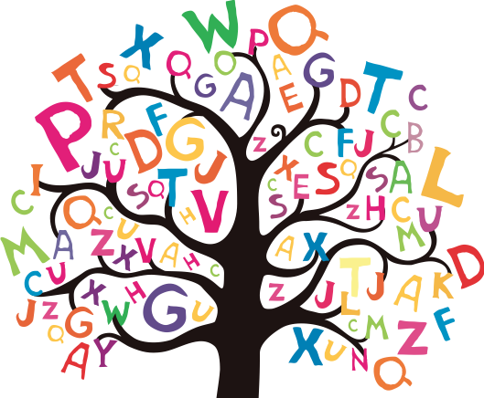

eight
weight
weigh
sleigh
neighbour

