Week 7 spellings Oak Class 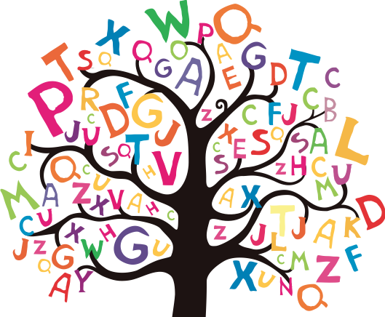

curious
obvious
serious
anxious
hideous
mountainous
dangerous
courageous
outrageous
humorous

