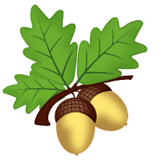
Oak Class Homework
Term 2
Priority homework:
Every week please read at least 5 times for at least 15 minutes at a time. This is the most important homework you can do. Reading regularly will improve your comprehension, spelling, grammar, creativity and general knowledge. You will also have spellings to learn and Mathletics to challenge yourself with! Don’t forget your multiplication tables too.
Title | Task | Return on
Photography Challenge | Your challenge is to take a photograph that represents AUTUMN. You can use a smartphone and email your photos to oakteacher@west-malling.kent.sch.uk. Think artistically – will you photograph nature or will you create your own autumn art?  If you would prefer you could also draw a picture that shows autumn. Will you draw a scene or maybe concentrate on one autumn leaf and its colours? | 9th November
Apples! | Now is the time of year when British apples are in season, however we see very few within our shops. Find out the names of different British varieties and  create a word search using the names for a friend to do in school. There will be a blank sheet for you to use if you wish! | 16th November
Get some fresh air! | Go on a lovely walk – can you complete the Autumn Hunt Checklist?  If the weather is too unpleasant for that, why not cosy up on the sofa and watch an episode of Autumn Watch on BBC iplayer?  https://www.bbc.co.uk/iplayer/episode/m000nwy8/autumnwatch-2020-episode-1 | 23rd November
Christmas  around the world | Find out about a Christmas tradition from another country. What is it? Where does it come from? How is it different to how we celebrate in this country? | 30th November
Christmas Stockings | Where does the tradition of Christmas Stockings come from?  Design one of your own! | 7th December
Christmas Cooking | Christmas is a great time for cooking, eating and sharing food! Cook something delicious to share with your family. | 14th December



