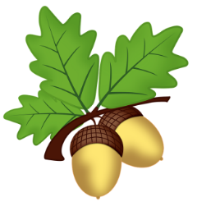
West Malling C. E. Primary School
Oak Class 2020
Curriculum Newsletter: Term Two

Dear Parents and Carers,

Welcome to Term 2! We can’t believe quite how fast last term went and we are now on the slippery slope to Christmas!
Please find our Term 2 curriculum updates and information on what we will be learning along with general information.

As always, if you have any questions, please do not hesitate to contact to any of Oak Team.

Mrs Hillsdon, Miss Richards, Mr White

English  Our class book is:  Tom’s Sausage Lion by Michael Morpurgo  Whilst exploring our new text, pupils in Oak will produce a variety of texts, including poetry, non-chronological report and playscripts.  Reading  Reading and understanding a text is a vital skill for your child’s future independence in learning and in life, but it needs to be continually practiced. Daily reading has been proven to have a noticeable effect on children’s reading and writing  ability, as well as their vocabulary and understanding of punctuation. Please continue to ensure that your child does read every day and ask them questions about the texts that they read.  Spelling  The children will continue to get weekly spellings in Oak class. These will be taken from the suggested words from the Year 4 curriculum and focus on spelling patterns included within these. The spellings will be sent home on Monday and we will test the children on Friday.  Punctuation  We will be revisiting apostrophes and learning about speech punctuation. | Mathematics  We will learn how to find and measure perimeters of shapes this term. Then it will be our multiplication and division term! We will be ensuring everyone has a good understanding of these operations before moving on and looking at the most effective way of calculating. Alongside this we will continue to problem solve and explain our thoughts using mathematical reasoning.  We continue to work on our 30/60/100/maths masters clubs weekly and of course, the multiplication tables!  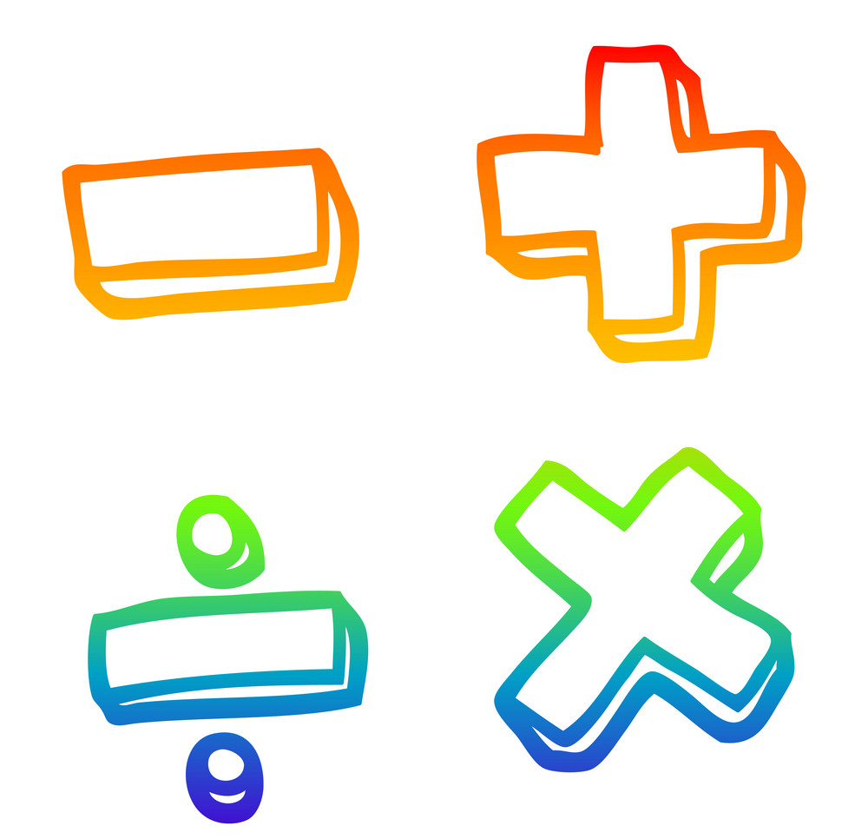 | Science  Our second science unit will see us exploring ‘States of Matter’. We will learn about the differences between solids, liquids and gases, classifying objects and identifying their properties.
Computing
This term we will develop our own game using the Scratch programming site alongside using the internet to research and refine our findings.

Music
Mrs Cripps will be teaching Oak class music on Fridays.


R.E.
Our second RE unit will see Oak pupils learn about the story of Abraham and Christians being ‘people of God’, including the role church communities take in aiding Christians live their faith.
 | History  We continue our exploration of Ancient Greece this term. We will learn about the Greek Gods, read Greek myths and find out about the life of Alexander the Great. We continue to develop our skills in research, looking at similarities and differences and to develop our understanding that there are reasons for people’s actions. | P.E.  PE will be on a Tuesday afternoon. This term we will benefit from having our wonderful specialist PE teacher Mrs Barratt working with Oak class!
French
In this term, we will continue with our learning on numbers, counting all the way to 100, in addition to expanding our conversational skills to include position, direction and transport.

Homework
Expectations of homework now include:
Maths – Mathletics practise will form the only maths homework set each week, alongside X tables.
Spellings – Children will receive their spellings on Monday (they will also be on our Oak webpage) to practise in school and at home, which will then be tested on Fridays.
Topic – This will be set at the beginning of each term. Although this is not compulsory, we advise that the children engage in this home learning as much as possible as it will have a positive impact on their learning in class. There will be a different activity for each week. Homework will be sent home during the first full week of Term 1 and is due in on a MONDAY. This will be marked in class and the pupils will bring their homework books home for the following week’s work. We love to share the great work they do on Oak webpage so keep your eye on there too!

Multiplication Tables
Year 4 have a government set multiplication tables test at the end of the academic year.
By the end of the 2020-21 school year, the children are expected to know their tables up to 12 x 12 with a 5 second recall.
Expectations are:
By the end of Y2: 2x 5x 10x
By the end of Y3: 3x 4x 8x
By the end of year 4: 6x 7x 9x 11x 12x

We will practise at school, but we ask that you also take as much time as you can to go through them at home. There are lots of websites where the children can play games, but nothing beats chanting them to get them to stick in their heads!
We will put links to some multiplication games back at the top of Oak webpage at the beginning of term.

Useful Reminders

A positive start to the day
As a reminder, Oak class timings are 8.35am – 2.50pm. Please do your best to ensure the children are in promptly at their time (we know that siblings have different times).

At the end of the day we will bring them to the netball court section of the playground and will send them over to you as we see you – please bear with us while we get to know all of you! Please do not encourage your child to come to you without our knowledge – we must ensure we are aware that everyone has been collected. Thank you for your help in this!
If you have siblings in the school, and therefore have been given a different collection or drop off time, we are aware of that so please don’t worry.

Learning Journals
We will not be using blue books at the moment- this will be reviewed as the year progresses. If you wish to communicate with the Oak staff please use our class email address:

Oakteacher@west-malling.sch.kent.uk

This term we have had a few technical issues with the Oak teacher email that have meant on some days we are unable to access it. Please bear with us – we think the problems are now solved!
If you have an urgent message that needs a response that day or to inform us of a change in who will collect your child, please let the office know by telephone and they will pass on the message. Thank you for understanding that we will be super busy in class and checking emails will mostly be out of school hours.

Snacks
Please pack a piece of fruit or veg for your child to snack on at playtime.

P.E.
Children are to come into school in their PE kits on Tuesdays. We now suggest they wear black leggings or tracksuit bottoms as it is getting colder. A school jumper or cardigan should be worn over their white PE t-shirt – please no other sweatshirts or hoodies.
Please ensure that stud earrings are removed on P.E. days and that long hair is tied back. We cannot be responsible for jewellery that is worn to school. If your child comes into school with earrings on a PE day and cannot remove them, unfortunately they will not be able to participate in PE lessons.

