Week 1 spellings Oak Class 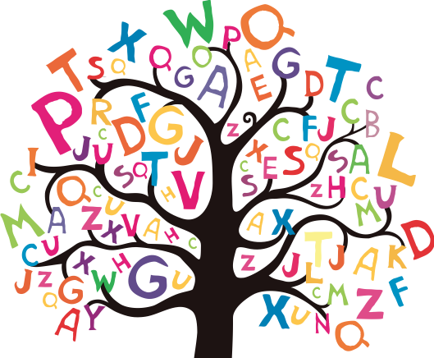

scent
science
scene
scissors
ascend
descend
fascinate
muscle
crescent
disciple

