Week 1 spellings Oak Class 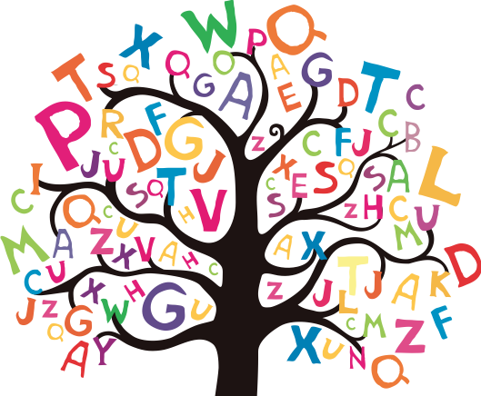

scene
scent
science
scissors
muscle

