Week 2 spellings Oak Class 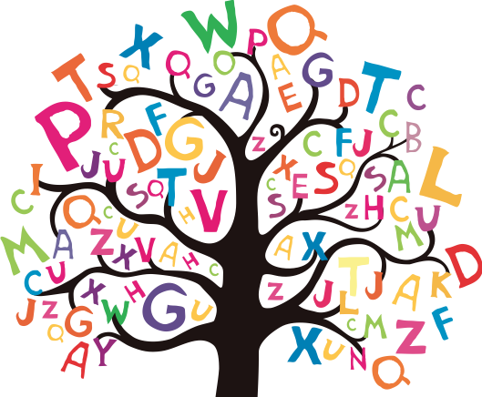

confusion
explosion
collision
decision
division
television
revision
occasion
diversion
invasion

