Week 2 spellings Oak Class 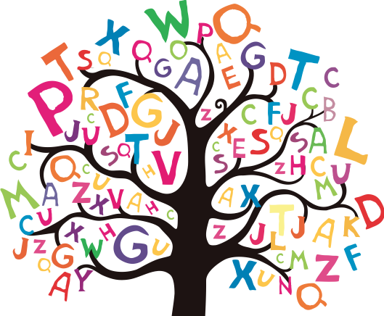

confusion
explosion
decision
division
television

