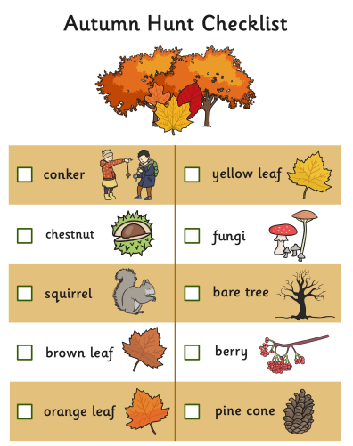
Can you spot any other signs of autumn?

