Week 3 spellings Oak Class 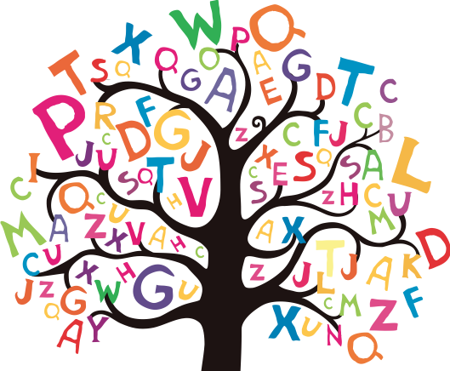

illegal
illogical
illegible
illiterate
incomplete
independent
incredible
impatient
important
impossible

