Week 3 spellings Oak Class 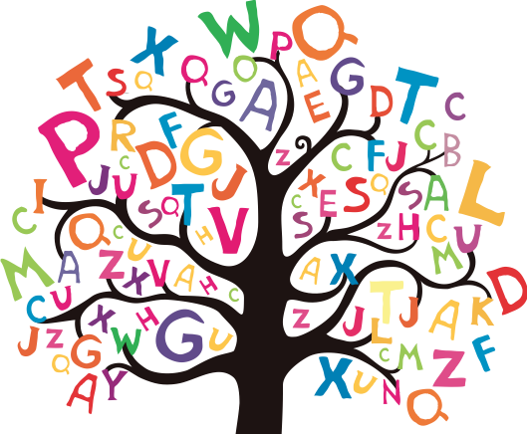

incomplete
independent
incredible
important
impossible

