Week 4 spellings Oak Class 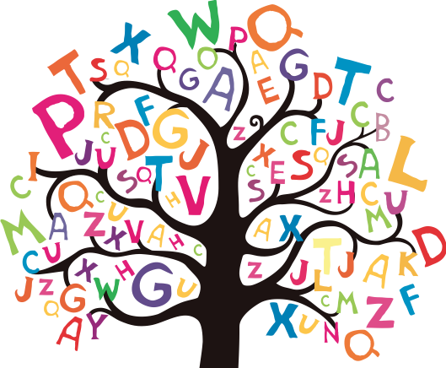

antique
unique
technique
cheque
grotesque
fatigue
league
dialogue
catalogue
tongue

