Week 3 spellings Oak Class 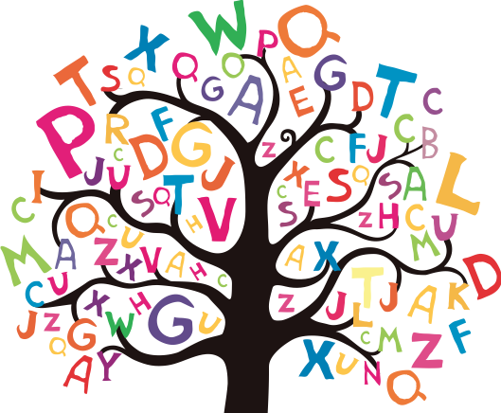

antique
unique
technique
cheque
grotesque

