Week 5 spellings Oak Class 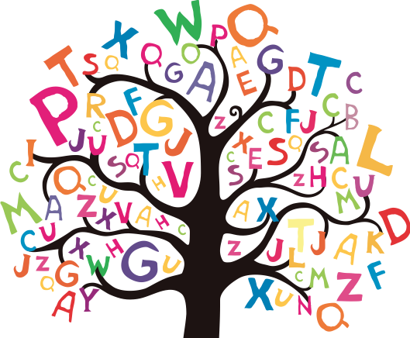

irregular
irresponsible
irresistible
irrelevant
irresistible
remember
strength
occasionally
accidentally
experience

