Week 6 spellings Oak Class 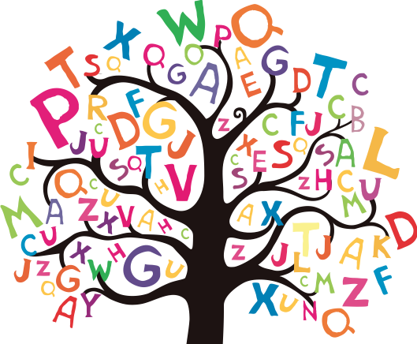

discussion
permission
confession
expression
impression

