Week 6 spellings Oak Class 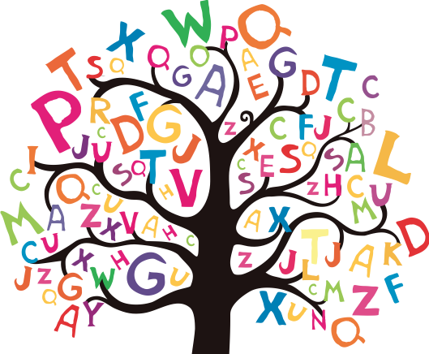

discussion
permission
confession
expression
obsession
admission
impression
possession
aggression
profession

