Week 7 spellings Oak Class 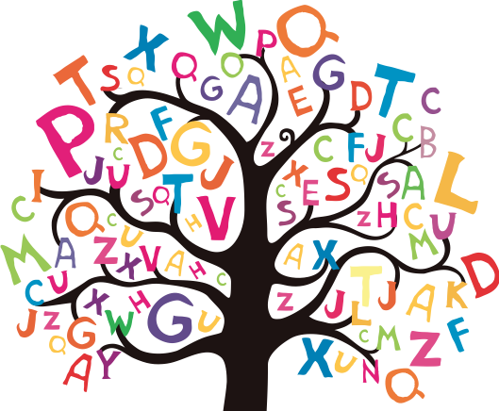

bauble
reindeer
fireplace
tradition
wreath

