Week 7 spellings Oak Class 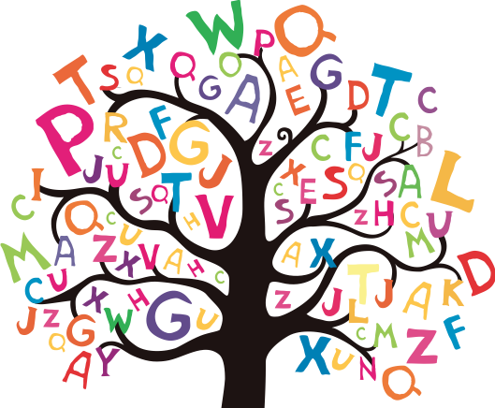

bauble
reindeer
decoration
celebration
chimney
fireplace
mistletoe
receive
tradition
wreath

