

Term 3 Challenge – Toe Taps

This is a test of speed, rhythm, balance, and coordination in a set time.

The challenge will be differentiated between Key stages by a varied amount of time to perform the challenge in.
- EYFS – 20 seconds
- Key stage 1 – 30 seconds
- Key stage 2 – 45 seconds.

Toe Taps – using a football or similar ball (If at home children can use a cushion or step to complete this challenge) children will need to stand behind the ball and place one foot on top of the ball at a time, after they have tapped the ball with their foot they will place that foot back on the floor and use their other foot to tap the ball.

EYFS and Key Stage 1 may need to be encouraged to do this as a marching action in a slow place in order to keep their balance.

Upper Key Stage 2 should be encouraged to stay on the ball of their foot and hop between toe taps to help with their speed and balance.

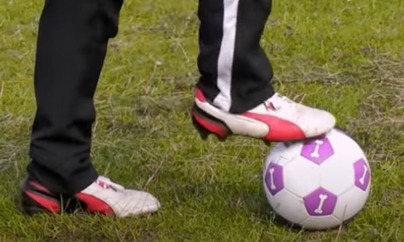
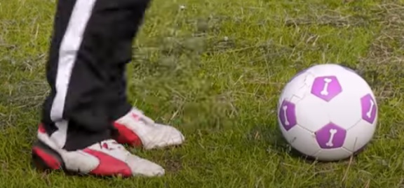
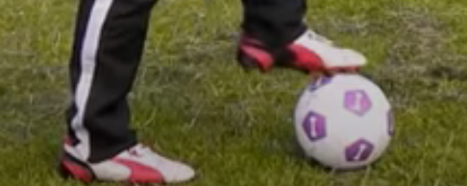

Count how many Toe Taps are performed in the time limit.

Rules:
- Starting on the whistle the participant must complete as many Toe Taps as possible in the time limit.
- Each time their foot touches the ball that will count as 1 toe tap
- Children must alternate feet with each toe tap, they can not keep tapping the ball with the same foot.
- The time stops on the whistle.

Tips:
- Two judges are recommended one for timing and one for counting. If not enough stop watches then class teacher can time for everyone at once.
- Keep the counter consistent so this remains a fair test.
- Ensure participants are wearing suitable, safe footwear.
- During the session try not to have everyone waiting around for their turn.
- Encourage children to practice on their own to attempt to improve their score.
- Repeat the personal challenge at the end of term and record the results to see if there has been an increase in their score.

For a video on how to complete this challenge please visit the PASS Website or Youtube page

Good Luck Everyone!

