Oak Class Homework Term 5
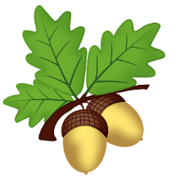
Priority homework:

Every week please read at least 5 times for at least 20 minutes at a time. This is the most important homework you can do. Reading regularly will improve your comprehension, spelling, grammar, creativity and general knowledge. You will also have spellings to learn and Mathletics to challenge yourself with! Don’t forget your multiplication tables too.

Title | Task | Return on
Multiplication  tables | Spend a week speeding up your recall and understanding of the times tables you need to learn. | Monday 26th April
May Day | There is a Bank Holiday on 3rd May this year – we get an extra day at home, but for your homework task can you find out why we celebrate it and what kind of traditions take place on it. | Tuesday 4th May
Multiplication  tables | Create a game that will help you learn your x tables. Choose from your 4x, 6x, 7x or 8x tables. Your game could be a simple matching card game or something far more extravagant! | Monday 10th May
Bird Hunt | You will be given a spring bird hunt sheet this week – throughout your week see how many of these birds you spot. They could be in your garden, while you are in the park or even on your journey to and from school. | Monday 17th May
Spelling marathon! | This week you will be given a huge list of HALF of the year 3 and 4 spelling words you will have learned over the last year and a half. Do your best to learn and remind yourself of them. Some you will be able to spell easily, others you may need to practise. There will be blank word search sheets for you to take home so if you wish you can make a wordsearch from them. You will NOT be tested on these! | Monday 23rd May



