Monday 23rd September
In this lesson, the children ordered three or more numbers up to 3-digits. They also worked out missing digits in lists of ordered numbers.
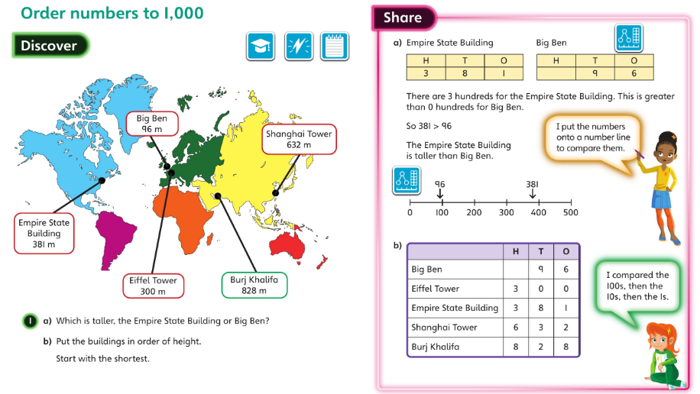

Tuesday 24th September
In this lesson, the children counted on and back in 50s from 0 to 1,000 and counted from any multiple of 50. They also worked out how many 50s there are in a number.
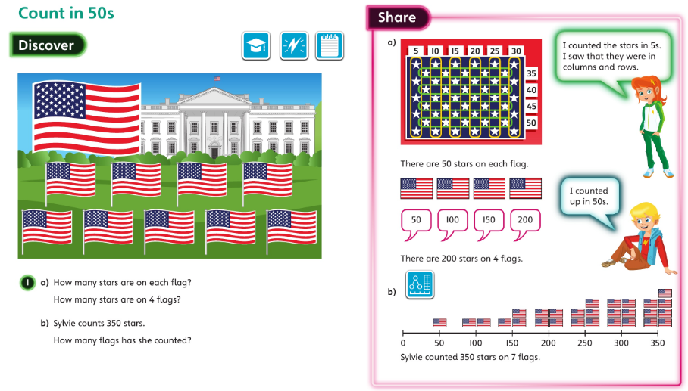

Wednesday 25th September and Thursday 26th September
The children completed an end of unit assessment.

Friday 27th September
In this lesson, the children used their knowledge of number bonds within 10 to add and subtract multiples of 100, up to 1,000.


