Monday 16th September
The children began to understand where numbers lie on a number line. They identified numbers that lie between two points.
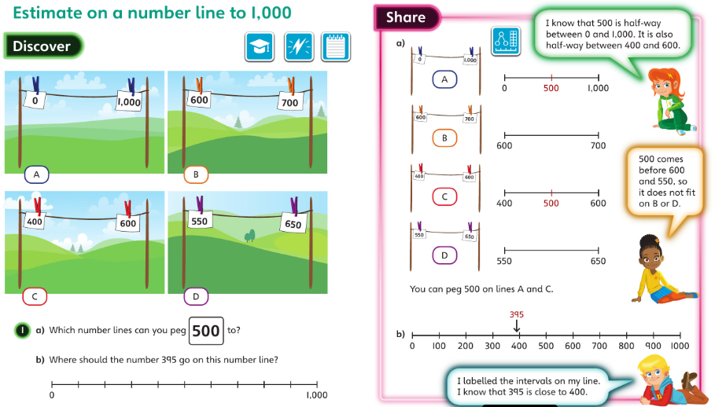

Tuesday 17th September
The children will find 1, 10 and 100 more or less than a given number (including cases that require an exchange). They also found the original number given the increase or decrease.
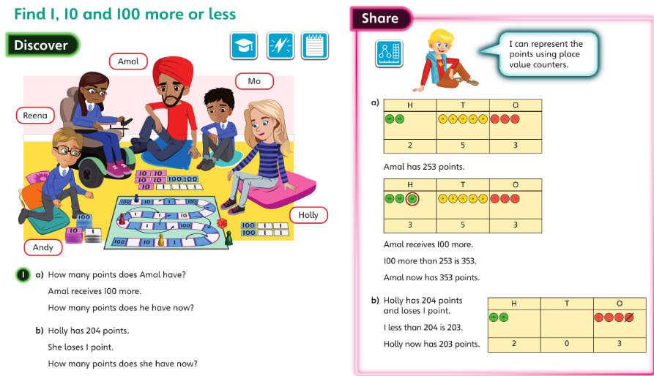

Wednesday 18th September
The children compared two 3-digit numbers. They also worked out missing digits to make an inequality statement correct.


