Monday 9th September. The children learnt to understand that a number up to 1,000 is made up of some 100s, some 10s and some 1s. They used base 10 equipment and part-whole models to represent numbers.
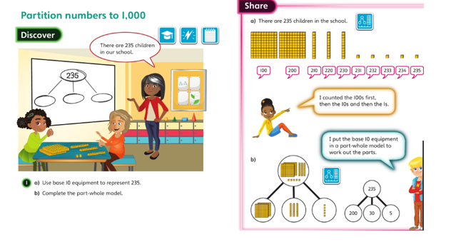

Tuesday 10th and Wednesday 11th September. The children built on their understanding of 3-digit numbers and learnt that they can be partitioned in different ways. They used base 10 equipment and part-whole models to represent 3-digit numbers.
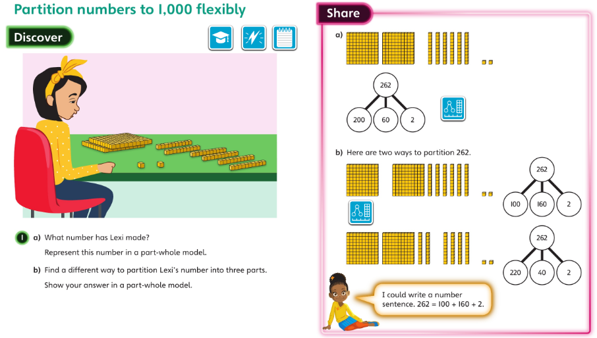

Thursday 12th September. The children represented numbers in place value grids using counters. They also wrote numbers represented with counters in a place value grid.
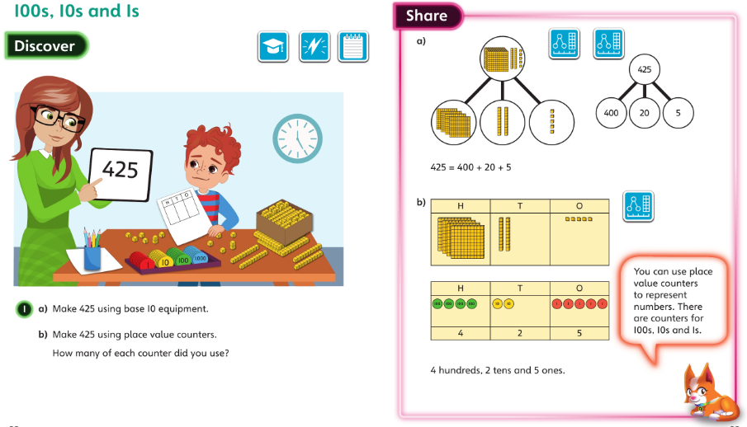

Friday 13th September. The children identified values and marked points on number lines that go up in 100s, 10s and 1s.



