Monday 30th September
In this lesson, the children added and subtracted a 1-digit number to and from a 3-digit number, using their understanding of place value. In this lesson, the children did not cross 10s.
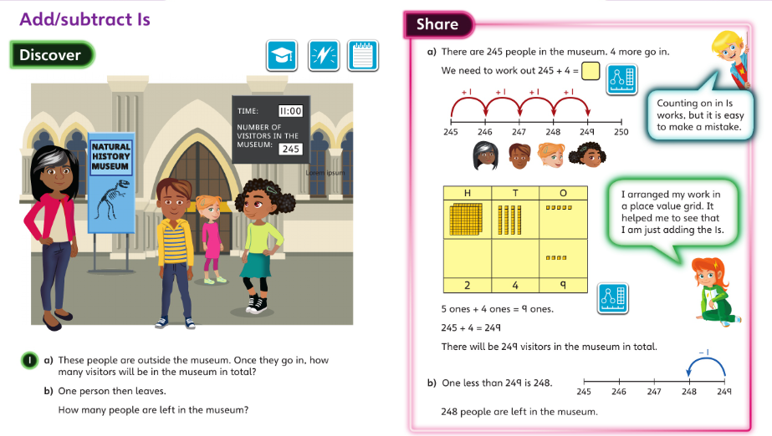

Tuesday 1st October and Wednesday 2nd October
In this lesson, the children added and subtracted multiples of 10 to and from a 3-digit number by using their knowledge of number bonds to add and subtract the 10s digits.
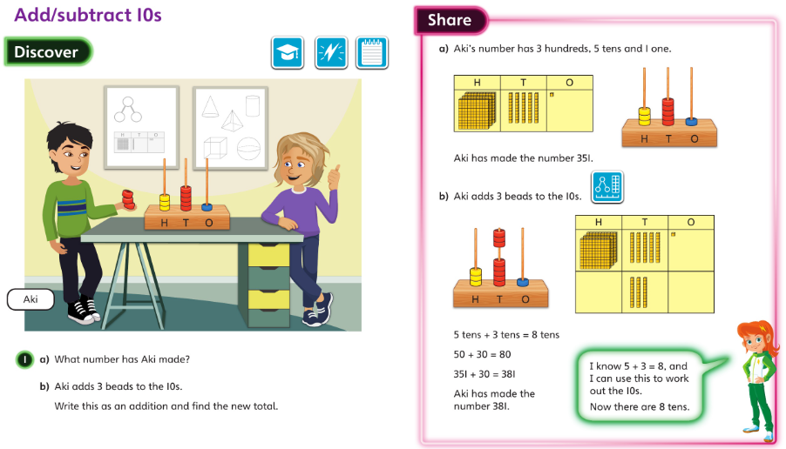

Thursday 3rd October
In this lesson, the children added a multiple of 100 to a 3-digit number by using their knowledge of number bonds to add the 100s digits.
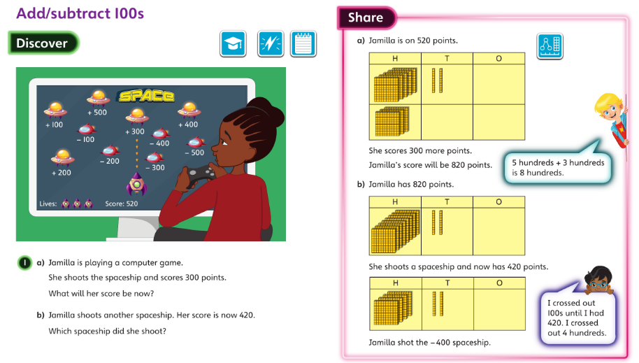

Friday 4th October
In this lesson, the children explored patterns in addition and subtraction and the effect on different digits of adding or subtracting 1s, 10s or 100s. At this stage, they did not explore calculations requiring exchange.


