07.10.24
In this lesson, the children understood how to recognise additions where they cross a 10, and learnt how to use exchange of 10 ones for 1 ten.
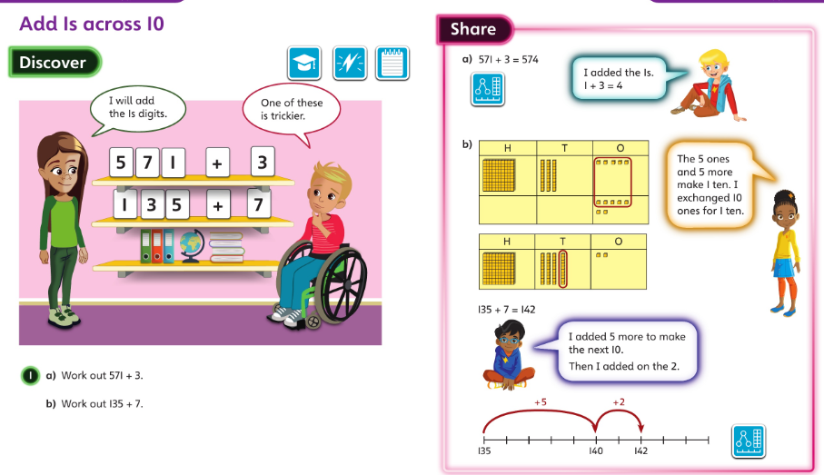

08.10.24
In this lesson, the children developed their understanding of adding 10s to a 3-digit number, including examples which require exchange of 10 tens for 1 hundred.
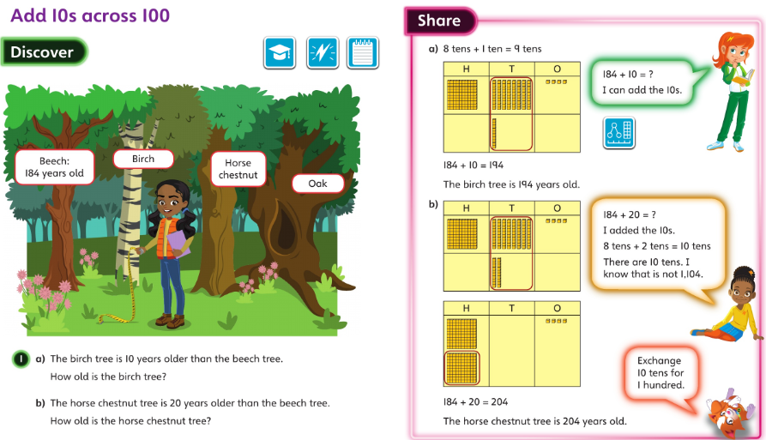

09.10.24
In this lesson, the children subtracted a 1-digit number where the subtraction crosses a 10. The children understood how to exchange 1 ten for 10 ones.
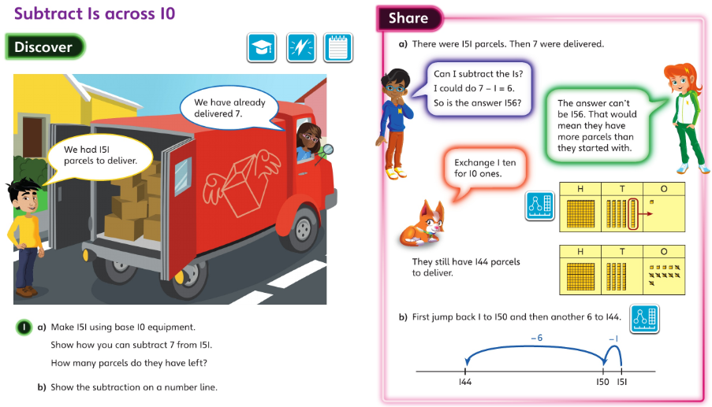

10.10.24
In this lesson, the children subtracted a multiple of 10 from a 3-digit number, including where they had to exchange 1 hundred for 10 tens.

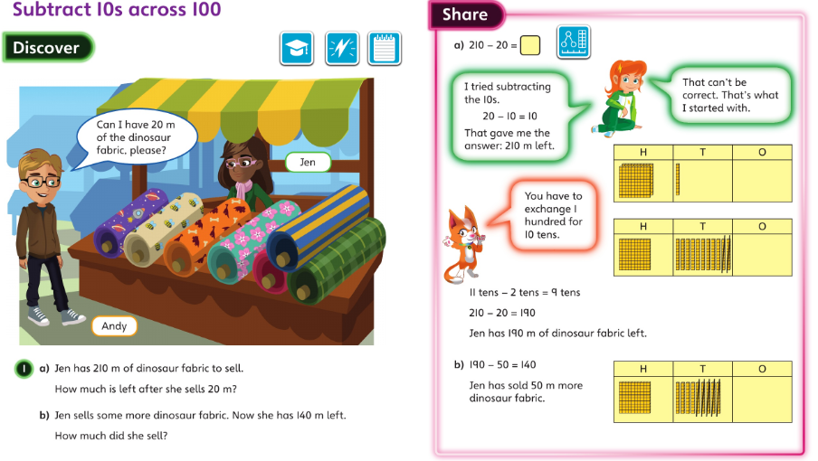

11.10.24
In this lesson, the children focussed on using simple calculations to find the answer to more complex calculations. They used their number bonds within 10 to break calculations down into more manageable steps and then use related facts to work out other calculations.


