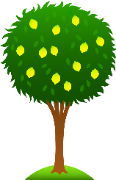 Our World!
Lime Class Home Learning – Term1
Maths  - Practise writing numbers 1-20 correctly. Please help your child to write these numbers correctly. (You could use paints, chalk, pens).  - Say a number, can your child write the number? (Particularly practise the ‘teen’ numbers e.g. 17 not 71).  - Have a go at filling in this number line. Can you write the numbers as words?  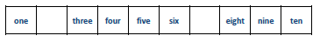  - Can you fill in these dominoes? Make sure you count the dots carefully.  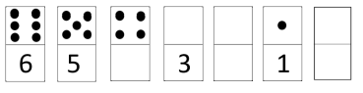  - Practise using the greater than > and less than < signs. Remember: the crocodile always eats the bigger number!  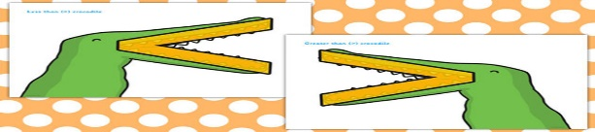  This Photo by Unknown Author is licensed under CC BY-NC-ND  - Practise logging into Mathletics independently. | English  - Practise writing your name and forming all letters correctly, including capital letters. Have a go at other letters too.  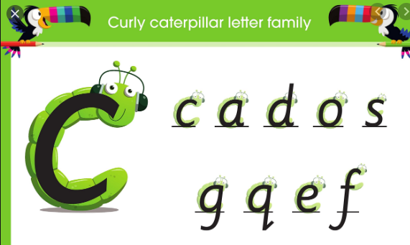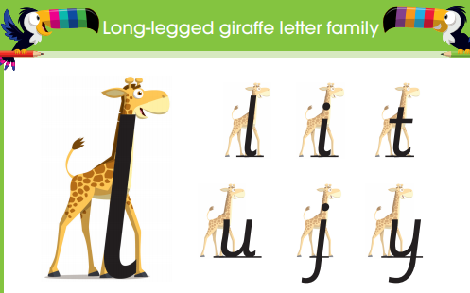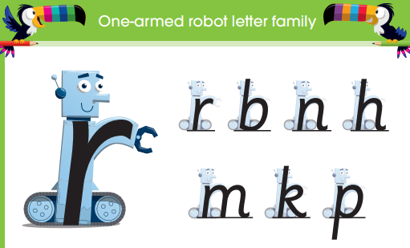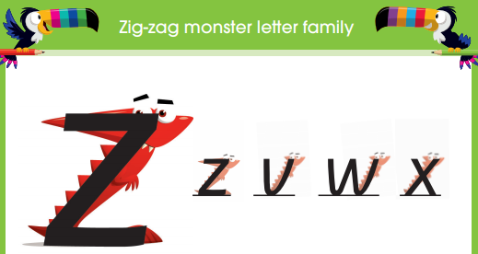  - Have a go at reading and writing these Year 1 words.  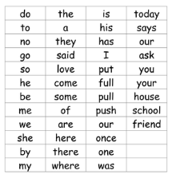  - Learn the letter names of the letters in the alphabet.  - Practise logging into Bug Club independently.
Science- Seasonal Changes  - Sing the months of the year. Learn what month your birthday is in. What season is that month in?  - What are the four seasons? Can you do a different piece of art work for each season? | Topic- Our world  - Find your house on Google Maps or on Google Earth. Can you work out your route to school?  - What are the 7 continents?  - Which continent do we live on?
- Children can use this home learning book to record any of their investigations (they could draw pictures, do some writing, put in photographs or stick in anything they have collected).

Please bring in your Home Learning books on Monday 19th October to share your work. Please use your books for any other English or Maths work you have been doing.

