
Monday 4th January 2021

Good morning Lime Class and Happy New Year!
I am so sad to not be seeing you all today and am missing you already.

I am excited to let you know that the whole class will have the opportunity to get together over ZOOM for a catch up and a quick lesson on Tuesday and a story on Friday this week at 11.30am. Try to have any work you have done nearby so that we can share each other’s learning. But most importantly I want to see you!
I will send the link and meeting details by the end of today. Please use the same link each time and let me know in advance if you are unable to join.

Whist we are not in school I will be setting work each day for you to have a go at.
Please find your learning for today below.
If you have any issues, please do let me know as I am very happy to help in any way I can.
Please stay in close contact and email your learning each day to limeteacher@west-malling.kent.sch.uk
I would also love to hear about any holiday news or show and tell you have to share. So please send me an email today and let me know if you would like your news shared with your friends on the class webpage.
Maths
This week we are going to be looking at Shape.
Today we are recognising and naming 3D shapes.

Watch this video: https://vimeo.com/476287832 (Don’t worry about doing the worksheet part)

The video will ask you to recognise and name the 3D shapes used in different models the children have made.

Now complete the 2 mathletics tasks I have set you about cubes and cylinders.

I have added 2 optional sheets which can be printed if you want to. Questions 1 and 2 you can talk about with an adult and question 3 you could write the answers onto a piece of paper.
Reading
Read for AT LEAST 10 minutes every day.

I know you can do it as we would normally do a lot more when we are at school.
I would love you all to use BugClub everyday as the Bug questions teach important reading skills that we would normally be covering in lessons. Every day, I will check to see who has read and how you have got on with the questions.
If you would prefer not to use a screen to read all of the time, it is absolutely fine to read books you have at home.
Reading every day is the most important thing to do.
Phonics and Tricky ‘red’ Words
This week’s ‘red’ words:
the
you
he
me
we
she
be
Each day, I will be giving you a sound to practice or recap. It will have the rhyme that we use to help us to learn it and some real words that contain the special friend. Have a go at reading the words and writing them making sure you use your ‘Fred Fingers’ to help you. There will also be some nonsense words to go with each sound for you to practice reading.
Each week, there will be 7 ‘red’ words for you to learn how to read and spell. 2 of these will be words we have looked at before and 5 will be new ones. Have a go at reading them and writing them, either as a list or in a sentence – You can get a cat. We can go to the zoo. Remember capital letters, finger spaces and full stops!

English
Today we will begin our new English unit.
We will be using the Story of Jack and the Beanstalk to help us.

As you are watching the video:
Listen and look out for why Jack and his Ma are sad.
Listen and look out for all the food that is mentioned.

Watch this video: ‘1. What shall we do?’ https://www.bbc.co.uk/teach/class-clips-video/english-ks1-jack-and-the-beanstalk-pt1/zjnc7nb

After you have watched the video, have a go at answering these questions: (Tell your answers to an adult)
What was Jack daydreaming about at the beginning of the story?
Why was Ma sad?
What did Jack and his Ma have on their shelves?

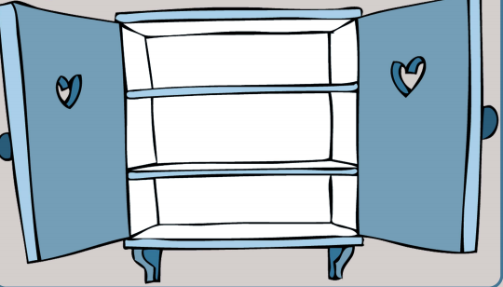
Activity 1
What other yucky things might be on Jack’s shelves.
Draw and write your ideas.
Try and describe what each thing is like.

For example: a rotten pear.

Activity 2
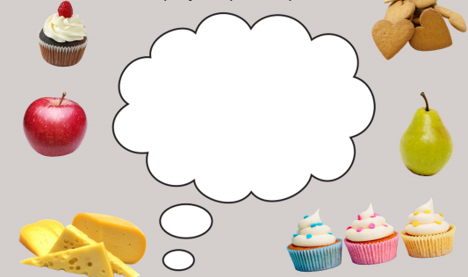
What lovely things would you daydream about if you were Jack?
Draw or write your ideas.

I hope you have had a fantastic day of learning. Remember, we will have a zoom meeting tomorrow at 11.30am. I will send the zoom invite by the end of the day. If I haven’t received an email from parents since September, please could you email the class address, so I have an up to date email address for you to receive the Zoom invitation. Thank you!

