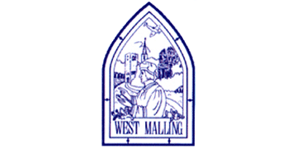
Tuesday 5th January 2021

Good morning Lime Class!
I am so sad to not be seeing you all today and am missing you already.

I am really looking forward to our get together over ZOOM for a catch up and a quick science lesson today at 11.30am. Try to have any work you have done nearby so that we can share each other’s learning. But most importantly I want to see you!
Hopefully you will have received your email with the link. Let me know if you haven’t. Please use the same link each time and let me know in advance if you are unable to join.

Please find your learning for today below.
If you have any issues, please do let me know as I am very happy to help in any way I can.
Please stay in close contact and email your learning each day to limeteacher@west-malling.kent.sch.uk
I would also love to hear about any holiday news or show and tell you have to share. So please send me an email today and let me know if you would like your news shared with your friends on the class webpage.
Maths
This week we are going to be looking at Shape.
Today we are sorting 3D shapes.

Watch this video: https://vimeo.com/477200613 (Don’t worry about doing the worksheet part)

The video will ask you to sort 3D shapes by their name, colour, whether they can be stacked and whether they can roll.

Now complete the Mathletics activity on sorting 3D shapes.

I have added 2 optional sheets which can be printed if you want to. Questions 1, 2 and 4 you can talk about with an adult and point to the screen. Question 5 you could draw 3 circles and write the letters of each shape in them. (There is no question 3)
Reading
Read for AT LEAST 10 minutes every day.

I know you can do it as we would normally do a lot more when we are at school.
I would love you all to use BugClub everyday as the Bug questions teach important reading skills that we would normally be covering in lessons. Every day, I will check to see who has read and how you have got on with the questions.
If you would prefer not to use a screen to read all of the time, it is absolutely fine to read books you have at home.
Reading every day is the most important thing to do.
Phonics and Tricky ‘red’ Words
Each day, I will be giving you a sound to practice or recap. It will have the rhyme that we use to help us to learn it and some real words that contain the special friend. Have a go at reading the words and writing them making sure you use your ‘Fred Fingers’ to help you. There will also be some nonsense words to go with each sound for you to practice reading.
This week’s ‘red’ words:
the
you
he
me
we
she
be
Each week, there will be 7 ‘red’ words for you to learn how to read and spell. 2 of these will be words we have looked at before and 5 will be new ones. Have a go at reading them and writing them, either as a list or in a sentence – You can get a cat. We can go to the zoo. Remember capital letters, finger spaces and full stops!

English
Today we will be carrying on with the story of Jack and the Beanstalk.

Before you watch the video: Do you know what a pail is?
It’s another word for a bucket. Have you ever seen a cow being milked?

As you are watching the video:
Listen and look out for how Jack is feeling.

Watch this video: ‘2: We have to Sell Daisy’ - https://www.bbc.co.uk/teach/class-clips-video/english-ks1-jack-and-the-beanstalk-pt2/z7ykxyc

After you have watched the video, have a go at answering these questions: (Tell your answers to an adult)
Why was Jack sad?
Why do they need to sell Daisy?
What does Jack hope, as he goes to sleep?

Activity: Story Sentences.

Can you recall what happens in this part of the story?
Look at the pictures below. Write a sentence for each one to retell this part of the story.
Remember capital letters, finger spaces and full stops!

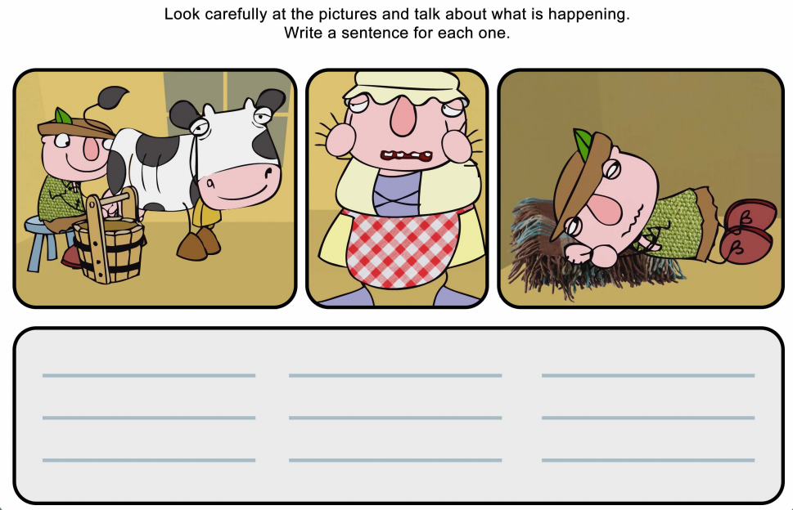
I hope you have another fantastic day of learning. Remember, we will have a zoom meeting today at 11.30am. I am looking forward to seeing you all and sharing our learning. I will also be doing a quick science lesson which will help you complete an independent science activity.

