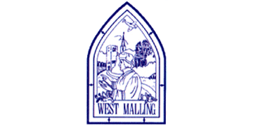
Wednesday 6th January 2021

Good morning Lime Class!

It was lovely seeing so many of you on our Zoom session yesterday! I hope you all enjoyed seeing each other and joining in with some of our learning, just like we would in class.

Please find your learning for today below.
If you have any issues, please do let me know as I am very happy to help in any way I can.
Please stay in close contact and email your learning each day to limeteacher@west-malling.kent.sch.uk
I would also love to hear about any holiday news or show and tell you have to share. So please send me an email today and let me know if you would like your news shared with your friends on the class webpage.
Maths
This week we are going to be looking at Shape.
Today we are moving on to recognise 2D shapes.

Watch this video: https://vimeo.com/420581449 (Don’t worry about doing the worksheet part)

The video will ask you to recognise 2D shapes from a selection checking that you know the names. You will then be shown some pictures and say what 2D shapes have been used to create them.

Now complete the Mathletics activity on matching shapes.

Todays activity is taken from the video. Use 2D shapes to create your own shape pictures. What shapes will you use? Can you create a picture using a triangle, circle, rectangle and square? Will you draw it or use objects to create it?

Reading
Read for AT LEAST 10 minutes every day.

I know you can do it as we would normally do a lot more when we are at school.
I would love you all to use BugClub everyday as the Bug questions teach important reading skills that we would normally be covering in lessons. Every day, I will check to see who has read and how you have got on with the questions.
If you would prefer not to use a screen to read all of the time, it is absolutely fine to read books you have at home.
Reading every day is the most important thing to do.

Phonics and Tricky ‘red’ Words
Each day, I will be giving you a sound to practice or recap. It will have the rhyme that we use to help us to learn it and some real words that contain the special friend. Have a go at reading the words and writing them making sure you use your ‘Fred Fingers’ to help you. There will also be some nonsense words to go with each sound for you to practice reading.
This week’s ‘red’ words:
the
you
he
me
we
she
be
Each week, there will be 7 ‘red’ words for you to learn how to read and spell. 2 of these will be words we have looked at before and 5 will be new ones. Have a go at reading them and writing them, either as a list or in a sentence – You can get a cat. We can go to the zoo. Remember capital letters, finger spaces and full stops!

English
Today we will be carrying on with the story of Jack and the Beanstalk.

Before you watch the video: Have you ever been to a market? What was it like? What happens at a market?
Some markets sell animals.

As you are watching the video:
Listen and look out for what the market is like.
Listen for the sounds that Jack hears.

Watch this video: 3: ‘Jack went to market.’ - https://www.bbc.co.uk/teach/class-clips-video/english-ks1-jack-and-the-beanstalk-pt3/zdnc7nb

After you have watched the video, have a go at answering these questions: (Tell your answers to an adult)
Why did Jack plead with his ma?
How much money did Jack’s Ma want for Daisy?
What was it like at the market?
What other animals were for sale?

Activity 1: Match the sound.
Can you recall what sounds Jack hears at the market? Use the sheet below to match the sounds with the pictures then have a go at writing a sentence about the sound each animal is making.
Activity 2: I went to the market and I saw
Can you remember what Jack saw and heard at the market? Play a game of ‘I went to the market and I saw’ with an adult or a brother/sister. You need to list everything that has been said before and add one more item.

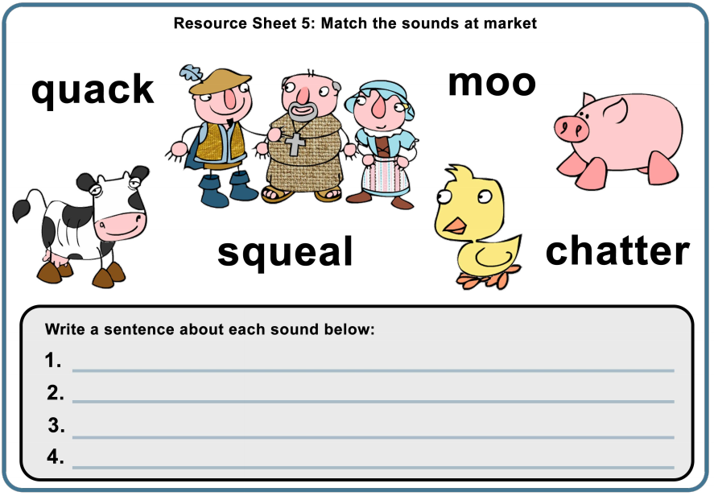
I hope you have another fantastic day of learning. Do email me if there is anything I can help you with or if you have any questions. I look forward to seeing some more of your amazing learning throughout the day.

