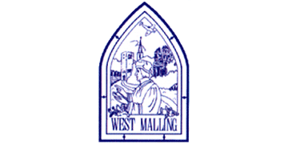
Thursday 7th January 2021

Good morning Lime Class!

I hope you had another good day of learning yesterday. How did you get on with the RE lesson?

Please find your learning for today below.
If you have any issues, please do let me know as I am very happy to help in any way I can.
Please stay in close contact and email your learning each day to limeteacher@west-malling.kent.sch.uk
I would also love to hear about any holiday news or show and tell you have to share. So please send me an email today and let me know if you would like your news shared with your friends on the class webpage.
Maths
This week we are going to be looking at Shape.
Today we are moving on to sorting different shapes.

Watch this video: https://vimeo.com/420581566 (Don’t worry about doing the worksheet part)

The video will ask you to sort shapes by colour and shape then into 2D shapes and 3D shapes. This is a good way for you to practice the names of the shapes. You may want to have a go at this practically too. Then it is your turn to say how the shapes have been sorted. Look very carefully!

Now complete the Mathletics activity on collecting simple shapes.

Today I have added 2 optional sheets which can be printed if you want to. The first two questions you can talk about with an adult and point to the screen. For question 3 I would like you to write the whole sentences and copy the correct word from the pictures of the shapes. You may want to be creative and have a go at printing with a 3D shape to help you (a can of beans for a cylinder, a ball for a sphere or a dice for a cube).

Reading
Read for AT LEAST 10 minutes every day.
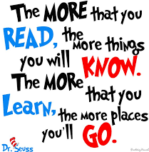
I know you can do it as we would normally do a lot more when we are at school.
I would love you all to use BugClub everyday as the Bug questions teach important reading skills that we would normally be covering in lessons. Every day, I will check to see who has read and how you have got on with the questions.
If you would prefer not to use a screen to read all of the time, it is absolutely fine to read books you have at home.
Reading every day is the most important thing to do.

Phonics and Tricky ‘red’ Words
Each day, I will be giving you a sound to practice or recap. It will have the rhyme that we use to help us to learn it and some real words that contain the special friend. Have a go at reading the words and writing them making sure you use your ‘Fred Fingers’ to help you. There will also be some nonsense words to go with each sound for you to practice reading.
This week’s ‘red’ words:
the
you
he
me
we
she
be
Each week, there will be 7 ‘red’ words for you to learn how to read and spell. 2 of these will be words we have looked at before and 5 will be new ones. Have a go at reading them and writing them, either as a list or in a sentence – You can get a cat. We can go to the zoo. Remember capital letters, finger spaces and full stops!

English
Today we will be carrying on with the story of Jack and the Beanstalk.

Before you watch the video: Recall the main points of the story so far. Can you remember why Jack is selling Daisy? How much did Ma say she wanted Jack to sell Daisy for? Why is Jack upset about selling Daisy?

As you are watching the video:
Listen and look out for what things people say to Jack.
Listen for the things that Jack thinks to himself.

Watch this video: 4: ‘Five Magic Beans.’ - https://www.bbc.co.uk/teach/class-clips-video/english-ks1-jack-and-the-beanstalk-pt4/z642f4j

After you have watched the video, have a go at answering these questions: (Tell your answers to an adult)
Why doesn’t anyone want to buy Daisy?
Why did Jack think Ma would be cross?
What does the old man offer Jack instead of money?

Activity 1: Writing question.
Can you remember any questions that were asked in the video? What do we need at the end of a question – would we write a full stop or a question mark? Have a go at finding the questions on the sheet below and adding a question mark at the end. To challenge yourself, try writing two questions that Jack could ask the old man.
Activity 2: Agree or disagree; what should Jack do?
What do you think Jack should do at the end? Should he sell Daisy to the old man? Do you think that 5 magic beans are as valuable as 5 coins? Why does Jack worry about what Ma might say? What might happen if he does not sell Daisy? Do you think the old man is telling the truth?

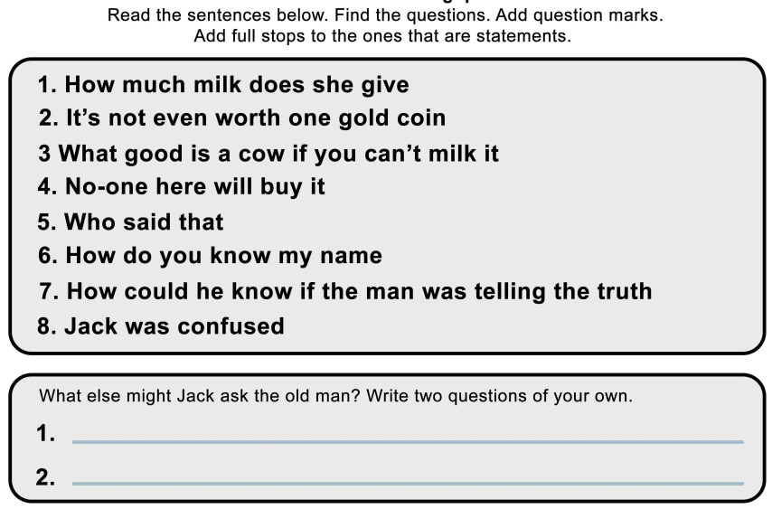
I hope you have another fantastic day of learning. Do email me if there is anything I can help you with or if you have any questions. I look forward to seeing some more of your amazing learning throughout the day.

Topic - Geography
Today we are going to be starting our new topic on Brazil. I think you are going to love learning about it!
For our first lesson, we will be naming the seven continents of the world – think back to the song we learnt earlier this year to help you remember – before we zoom into South America and locating Brazil. We will be looking at some physical and human features that are found in Brazil and then compare them to where we live in the UK.

You will need a pen and some paper to complete the activities.

Here is the link to the video for you to watch: https://classroom.thenational.academy/lessons/where-is-brazil-6nk3gr

Mums and Dads – The video is quite long; about 20 minutes. So, you could split it into 3 parts. Here are my suggestions:
First part – The introduction to Brazil up to 7 minutes 22 seconds.
Second Part – Up to the Physical features activity – 14 minutes.
Third part – Up to the end with the Human features activity.

There is also a fun quiz at the end to see how much you can remember!

