
Friday 8th January 2021

Good morning Lime Class!

We have made it to the end of our first week of remote teaching and learning! I think we all deserve a rest this weekend!

I am looking forward to seeing you all again later on this morning (11.30) for our Friday Zoom session. (Mums and Dads – it is the same details that I emailed to you earlier on this week.) I am really excited to be telling you who our learner of the week is! If you have any work or show and tell that you would like to share, please have it ready with you ready to show.

Please find your learning for today below.
If you have any issues, please do let me know as I am very happy to help in any way I can.
Please stay in close contact and email your learning each day to limeteacher@west-malling.kent.sch.uk

Maths
This week we are going to be looking at Shape.
Today we are moving on to patterns with 2D and 3D shapes.

Watch this video: https://vimeo.com/420698416 (Don’t worry about doing the worksheet part)

The video will ask you what are patterns? Have a think if you’ve seen any patterns anywhere. You will be looking at repeating patterns. Think about what comes next? What is missing? You may want to have a go at creating your own repeating pattern with objects or shapes.

Now complete the Mathletics activities on completing the pattern and the shape test.

Today I have added an optional sheet which can be printed if you want to. You can talk about the answers and point to the screen or you could write the answers on a piece of paper.

Reading
Read for AT LEAST 10 minutes every day.
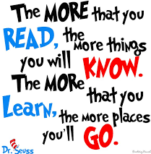
I know you can do it as we would normally do a lot more when we are at school.
I would love you all to use BugClub everyday as the Bug questions teach important reading skills that we would normally be covering in lessons. Every day, I will check to see who has read and how you have got on with the questions.
If you would prefer not to use a screen to read all of the time, it is absolutely fine to read books you have at home.
Reading every day is the most important thing to do.

Phonics and Tricky ‘red’ Words
Each day, I will be giving you a sound to practice or recap. It will have the rhyme that we use to help us to learn it and some real words that contain the special friend. Have a go at reading the words and writing them making sure you use your ‘Fred Fingers’ to help you. There will also be some nonsense words to go with each sound for you to practice reading.
This week’s ‘red’ words:
the
you
he
me
we
she
be
Each week, there will be 7 ‘red’ words for you to learn how to read and spell. 2 of these will be words we have looked at before and 5 will be new ones. Have a go at reading them and writing them, either as a list or in a sentence – You can get a cat. We can go to the zoo. Remember capital letters, finger spaces and full stops!

English
Today we will be carrying on with the story of Jack and the Beanstalk.

Before you watch the video: Recall the main points of the last episode. Who do you think the old man is? Do you think Jack will sell Daisy to him?

As you are watching the video:
Listen and look out for how Jack feels as the story continues.
Listen for how Ma reacts when Jack gets home.

Watch this video: 5: ‘Beans for the birds.’ - https://www.bbc.co.uk/teach/class-clips-video/english-ks1-jack-and-the-beanstalk-pt5/zfqncqt

After you have watched the video, have a go at answering these questions: (Tell your answers to an adult)
What does Jack make the old man promise?
How does Jack feel when he gives Daisy to the man?
What else does the old man give Jack as well as the beans?
What did Ma say when Jack told her what he had done?
How does Ma punish Jack?
Why is this episode called ‘Beans for the birds’? (Think about what happens at the end).

Activity: Writing question.
Talk about how Ma reacts when Jack gets home with the magic beans. How does Jack tell her? Remember that he asks her to close her eye. Why does he do this? Is she surprised? What happens when she finds out that Jack has got beans for Daisy instead of money? Use the sheet below to draw Ma’s face before and after she finds out. Write some words to describe how she feels.

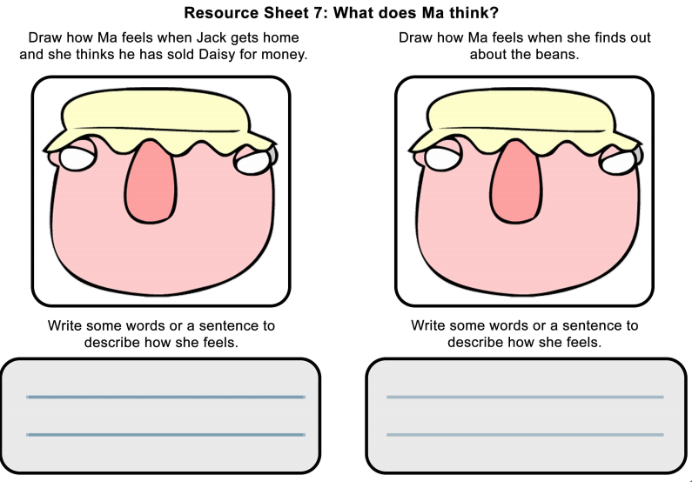
I hope you have another fantastic day of learning. Do email me if there is anything I can help you with or if you have any questions. I look forward to seeing you on Zoom later and receiving some more of your amazing learning throughout the day.

