
Monday 11th January 2021

Good morning Lime Class!
I hope you have all had a nice weekend and are ready for another week of amazing learning.

I am looking forward to our ZOOM session tomorrow at 11.30 where we can have a quick catch up and continue with our Science learning. Try to have any work you have done nearby so that we can share each other’s learning. But most importantly I want to see you!

Please find your learning for today below.

If you have any issues, please do let me know as I am very happy to help in any way I can.
Please stay in close contact and email your learning each day to limeteacher@west-malling.kent.sch.uk
I would also love to hear about any other news or show and tell you have to share. So please send me an email and let me know if you would like your news shared with your friends on the class webpage.
Maths
This week we are going to be looking at numbers to 20.
Today we are counting and writing numbers to 20.

Watch this video: https://player.vimeo.com/video/480768128 (Don’t worry about doing the worksheet part)

The video will ask you to count on from 10 using ten frames. You will practise counting backwards from 20 to 10 then work out how many there are on the ten frames. Next, you will need to think about how we write the ‘teen’ numbers and spot the mistakes on the number tracks and also to fill in the missing numbers. Think carefully about whether you are counting forwards or backwards.

Now complete the 2 mathletics tasks I have set you on counting up to 20 and matching numbers to 20.

Today I would like you to practise writing/forming the numbers 11 to 20. You can choose how you do this – pen, paint, sand, flour, water outside – be as creative as you like!
I have attached a ten frame activity where you need to count on from 10 and choose the correct number – no need to print this out. Have a go at using ten frames (draw them on paper) to create a ‘teen’ number. You could use counters, objects or draw them on yourself.
Reading
Read for AT LEAST 10 minutes every day.

I know you can do it as we would normally do a lot more when we are at school.
I would love you all to use BugClub everyday as the Bug questions teach important reading skills that we would normally be covering in lessons. Every day, I will check to see who has read and how you have got on with the questions.
If you would prefer not to use a screen to read all of the time, it is absolutely fine to read books you have at home.
Reading every day is the most important thing to do.

Phonics and Tricky ‘red’ Words
This week’s ‘red’ words:
said
was
no
so
go
old
her
Each day, I will be giving you a sound to practice or recap. It will have the rhyme that we use to help us to learn it and some real words that contain the special friend. Have a go at reading the words and writing them making sure you use your ‘Fred Fingers’ to help you. There will also be some nonsense words to go with each sound for you to practice reading.
Each week, there will be 7 ‘red’ words for you to learn how to read and spell. 2 of these will be words we have looked at before and 5 will be new ones. Have a go at reading them and writing them, either as a list or in a sentence – “Go to bed” said Mum. How old are you? Remember capital letters, finger spaces and full stops/question marks!

English
This week we will be continuing with our work on the Story of Jack and the Beanstalk. I have been so impressed with the work you have done on this already and can see that you are really understanding the story.

Before you watch the video: Recall the main points of the last episode. How do you think Jack is feeling when he is sent to bed that night?

As you are watching the video:
Listen and look out for what Jack wishes and dreams about.
Listen for the sounds you can hear in his episode.

Watch this video: 6: ‘And the beanstalk grew.’ - https://www.bbc.co.uk/teach/class-clips-video/english-ks1-jack-and-the-beanstalk-pt6/zn63d6f

After you have watched the video, have a go at answering these questions: (Tell your answers to an adult)
What does Jack wish as he goes to sleep?
What does Jack dream about in the night?
What happens while Jack was asleep?
What was the mysterious rustling sound?

Activity 1: Jack’s Dreams.
Talk about what Jack dreams about. What is happening while he is asleep?
Use the sheet below to draw some ideas for Jack’s dreams. Write a sentence to go with the picture.

Activity 2: Mysterious sounds in the night.
Watch the video again and listen carefully to the sounds you can hear. Can you create your own sounds using instruments or junk materials such as scrunched up paper? You could even use your voice to create the sounds. What sounds will you create – beanstalk rustling? Owl sounds? Crickets? A sound for a dream? Snoring for sleep? Rumbling sound?

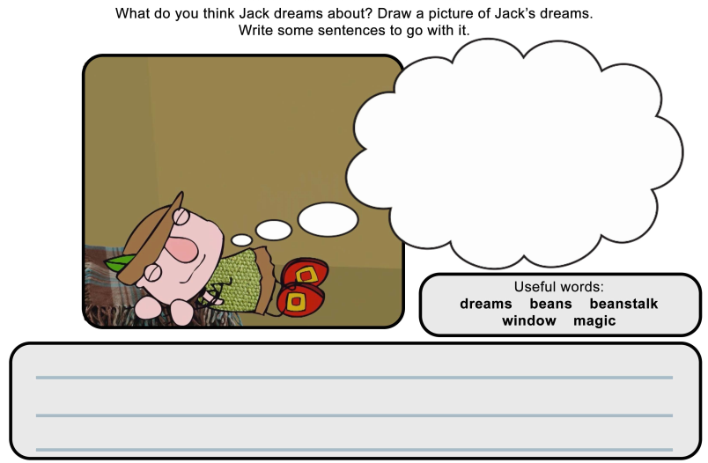

I hope you have a fantastic day of learning. Remember, we will have a zoom session tomorrow at 11.30am. It is the same details that I emailed to you last week. Do email me if there is anything I can help you with or if you have any questions.

