
Tuesday 12th January 2021

Good morning Lime Class!

I am really looking forward to our get together over ZOOM for a catch up and a quick science lesson today at 11.30am. Try to have any work you have done nearby so that we can share each other’s learning. But most importantly I want to see you! It is the same link and details that I emailed out last week. Do let me know if you need it to be resent.
Have a look at this short video as it will help you with our Science lesson later on:
https://www.bbc.co.uk/bitesize/topics/z9yycdm/articles/zxy987h
Please find your learning for today below.
If you have any issues, please do let me know as I am very happy to help in any way I can.
Please stay in close contact and email your learning each day to limeteacher@west-malling.kent.sch.uk
I would also love to hear about any other news or show and tell you have to share. So please send me an email today and let me know if you would like your news shared with your friends on the class webpage.

Maths
This week we are going to be looking at numbers to 20.
Today we are continuing counting and writing numbers to 20.

Watch this video: https://player.vimeo.com/video/480769444 (Don’t worry about doing the worksheet part)

In this video you will be looking at numbers 11 to 20 in different ways – ten frames, number blocks, straws and hands. You will be practising counting on from 10. Then you will need to find some objects on your house or draw some to create a number of your choosing from 11 to 20.

Now complete the Mathletics activity on ordering numbers to 20.

I have added 2 optional sheets which can be printed if you want to. Questions 1 and 2 - make sure that you count on from 10 to work out the answers. Questions 4 and 5 look carefully at the order of numbers – are you counting forwards or backwards? (There is no question 3)

Reading
Read for AT LEAST 10 minutes every day.

I know you can do it as we would normally do a lot more when we are at school.
I would love you all to use BugClub everyday as the Bug questions teach important reading skills that we would normally be covering in lessons. Every day, I will check to see who has read and how you have got on with the questions.
If you would prefer not to use a screen to read all of the time, it is absolutely fine to read books you have at home.
Reading every day is the most important thing to do.
Phonics and Tricky ‘red’ Words
Each day, I will be giving you a sound to practice or recap. It will have the rhyme that we use to help us to learn it and some real words that contain the special friend. Have a go at reading the words and writing them making sure you use your ‘Fred Fingers’ to help you. There will also be some nonsense words to go with each sound for you to practice reading.
This week’s ‘red’ words:
said
was
no
so
go
old
her

Each week, there will be 7 ‘red’ words for you to learn how to read and spell. 2 of these will be words we have looked at before and 5 will be new ones. Have a go at reading them and writing them, either as a list or in a sentence – “Go to bed” said Mum. How old are you? Remember capital letters, finger spaces and full stops/question marks!

English
Today we will be carrying on with the story of Jack and the Beanstalk.

Before you watch the video: Recall the main points of yesterdays video. What do you think has happened in the night? What will Jack see out of the window? Have you ever seen a beanstalk?

As you are watching the video:
Listen and look out for how Jack feels as he climbs the beanstalk.
Listen and look out for what Jack climbs past as he gets higher and higher.

Watch this video: 7: ‘And he went higher’ - https://www.bbc.co.uk/teach/class-clips-video/english-ks1-jack-and-the-beanstalk-pt7/z6mykmn

After you have watched the video, have a go at answering these questions: (Tell your answers to an adult)
Why is Jack’s room darker when he wakes up?
Why are Jack’s new shoes helpful?
How does Jack feel as he climbs?
What things does he climb past?

Activity1: Jack’s Climb
Can you act out Jack’s climb by moving on the spot? How was he feeling as he got towards the top? Can you pretend to look down?

Activity 2: Jack’s feelings beanstalk
Talk about how Jack’s feelings change as he climbs the beanstalk. Which words could you use to describe them? Use the sheet below to write down his feelings at different points on the beanstalk as he gets towards the top. Draw in the different things that he sees as he climbs, such as the chimney and the clouds.
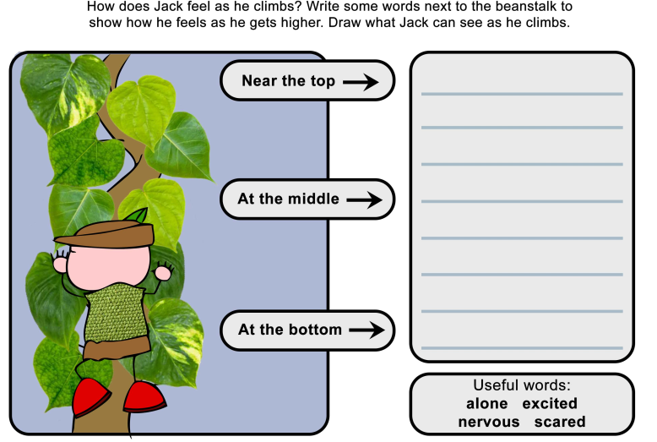

I hope you have another fantastic day of learning. Remember, we will have a zoom meeting today at 11.30am. I am looking forward to seeing you all and sharing our learning. I will also be doing a quick science lesson which will help you complete a fun science activity.

