
Wednesday 13th January 2021

Good morning Lime Class!

It was lovely seeing so many of you on our Zoom session yesterday! I hope you all enjoyed seeing each other and joining in with some of our learning, just like we would in class.

Please find your learning for today below.
If you have any issues, please do let me know as I am very happy to help in any way I can.
Please stay in close contact and email your learning each day to limeteacher@west-malling.kent.sch.uk
I would also love to hear about any other news or show and tell you have to share. So please send me an email today and let me know if you would like your news shared with your friends on the class webpage.
Maths
This week we are going to be looking at numbers to 20.
Today we are moving on to tens and ones.

Watch this video: https://player.vimeo.com/video/480324356 (Don’t worry about doing the worksheet part)

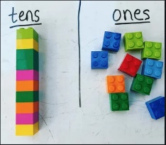
The video will ask you to work out how many tens and ones make a teen number for example, there is 1 ten and 7 ones is equal to 17. If you can, have a go at using some resources to help you like straws or Lego. Things that you can group together to make 1 ten.

Now complete the Mathletics activity on before, after and between to 20.

For todays activity I would like you to have a go at Making teen numbers using 1 ten and some ones. There is an example above with Lego to help you. If you feel ready, try the maths sheets I have added for you where you are using the pictures to write how many tens and how many ones. Can you show me the number using ten frames?
Reading
Read for AT LEAST 10 minutes every day.

I know you can do it as we would normally do a lot more when we are at school.
I would love you all to use BugClub everyday as the Bug questions teach important reading skills that we would normally be covering in lessons. Every day, I will check to see who has read and how you have got on with the questions.
If you would prefer not to use a screen to read all of the time, it is absolutely fine to read books you have at home.
Reading every day is the most important thing to do.

Phonics and Tricky ‘red’ Words
Each day, I will be giving you a sound to practice or recap. It will have the rhyme that we use to help us to learn it and some real words that contain the special friend. Have a go at reading the words and writing them making sure you use your ‘Fred Fingers’ to help you. There will also be some nonsense words to go with each sound for you to practice reading.
This week’s ‘red’ words:
said
was
no
so
go
old
her

Each week, there will be 7 ‘red’ words for you to learn how to read and spell. 2 of these will be words we have looked at before and 5 will be new ones. Have a go at reading them and writing them, either as a list or in a sentence – “Go to bed” said Mum. How old are you? Remember capital letters, finger spaces and full stops/question marks!

English
Today we will be carrying on with the story of Jack and the Beanstalk.

Before you watch the video: What do you think it will be like at the top of the beanstalk? You may already know what Jack finds if you have heard this story before. Listen carefully to how this version of the story describes the castle.

As you are watching the video:
Listen and look out for what it is like at the top of the beanstalk.
Listen and look out for how Jack finds his way to the castle.

Watch this video: 8: ‘The castle in the clouds’ - https://www.bbc.co.uk/teach/class-clips-video/english-ks1-jack-and-the-beanstalk-pt8/zbcmy9q

After you have watched the video, have a go at answering these questions: (Tell your answers to an adult)
What is it like at the top of the beanstalk? Talk about the world ‘barren’ which shows that it is a very bare empty land with nothing growing.
Why do you think Jack shivers when he gets to the top?
Which animal leads Jack to the path that goes to the castle?
What is the castle like?

Activity: Retell the episode.
Can you recall what happened in this episode? Have a look at the sheet below and match the pictures to the correct sentence.
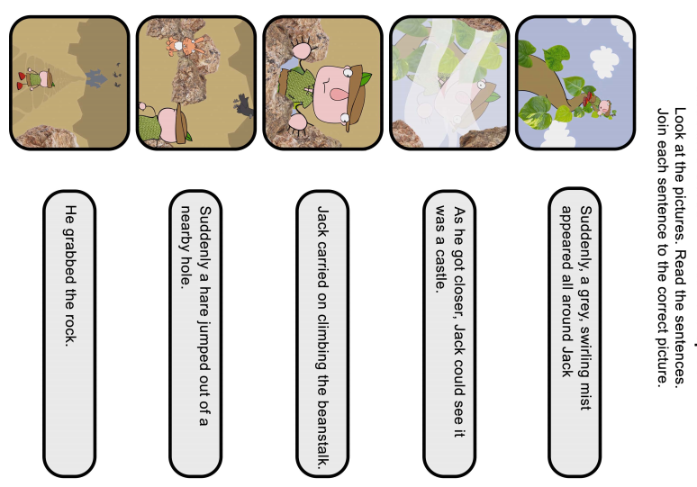

I hope you have another fantastic day of learning. Do email me if there is anything I can help you with or if you have any questions. I look forward to seeing some more of your amazing learning throughout the day.

