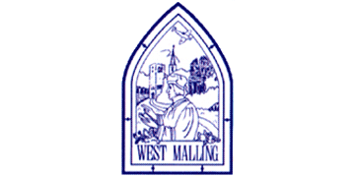
Thursday 14th January 2021

Good morning Lime Class!

I hope you had another good day of learning yesterday. How did you get on with the second RE lesson?

Please find your learning for today below.
If you have any issues, please do let me know as I am very happy to help in any way I can.
Please stay in close contact and email your learning each day to limeteacher@west-malling.kent.sch.uk
I would also love to hear about any other news or show and tell you have to share. So please send me an email today and let me know if you would like your news shared with your friends on the class webpage.
Maths
This week we are going to be looking at numbers to 20.
Today we are continuing looking at Tens and Ones.

Watch this video: https://player.vimeo.com/video/480325207 (Don’t worry about doing the worksheet part)

The video will ask you to show how many tens and how many ones, just like you did yesterday. Look carefully at the pictures! How many ones are in 20? You will then have a go at filling in the missing part of the number sentence.

Now complete the Mathletics activity on making teen numbers.

Today I have added 2 optional sheets which can be printed if you want to. You will notice it starts with Question 3 today! Have a go at matching the ten frames to the sentences and then filling in the missing part of the number sentence just like you did for the video. Question 3 on the second page could be done practically with resources if you want too! Question 6 is your challenge! Is it true or false? Can you explain why?
Reading
Read for AT LEAST 10 minutes every day.

I know you can do it as we would normally do a lot more when we are at school.
I would love you all to use BugClub everyday as the Bug questions teach important reading skills that we would normally be covering in lessons. Every day, I will check to see who has read and how you have got on with the questions.
If you would prefer not to use a screen to read all of the time, it is absolutely fine to read books you have at home.
Reading every day is the most important thing to do.

Phonics and Tricky ‘red’ Words
Each day, I will be giving you a sound to practice or recap. It will have the rhyme that we use to help us to learn it and some real words that contain the special friend. Have a go at reading the words and writing them making sure you use your ‘Fred Fingers’ to help you. There will also be some nonsense words to go with each sound for you to practice reading.
This week’s ‘red’ words:
said
was
no
so
go
old
her
Each week, there will be 7 ‘red’ words for you to learn how to read and spell. 2 of these will be words we have looked at before and 5 will be new ones. Have a go at reading them and writing them, either as a list or in a sentence – “Go to bed” said Mum. How old are you? Remember capital letters, finger spaces and full stops/question marks!

English
Today we will be carrying on with the story of Jack and the Beanstalk.

Before you watch the video: Who do you predict (have a guess) is in the castle? You may already know the story so listen carefully to how this version of the story may vary!

As you are watching the video:
Listen and look out for how the Giant’s wife helps Jack.
Listen out for what the Giant says.

Watch this video: 9: ‘Fee-fi-fo-fum’ - https://www.bbc.co.uk/teach/class-clips-video/english-ks1-jack-and-the-beanstalk-pt9/zkg7scw

After you have watched the video, have a go at answering these questions: (Tell your answers to an adult)
How does Jack know the Giant is coming?
How does the Giant’s wife help Jack?
What does the Giant say?
What does the Giant want to do with Jack?

Activity 1: Sequence the episode.
Can you retell what happens in this episode? Cut out and order the pictures on the sheet below. If you are not able to print the sheet, then point and order the pictures on the screen. Have a go at writing a sentence about each one.
Activity 2: Giant voices.
Listen again to the episode and pay attention to how the Giant speaks. Read these sentences using your best Giant voices!
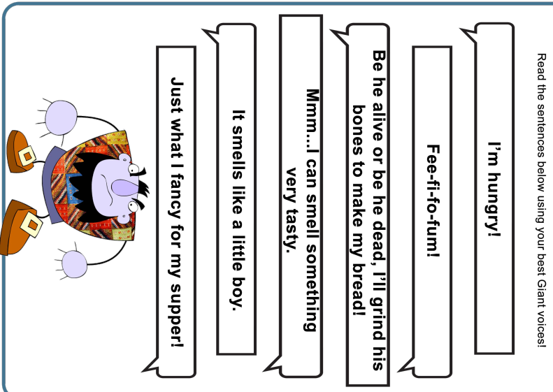

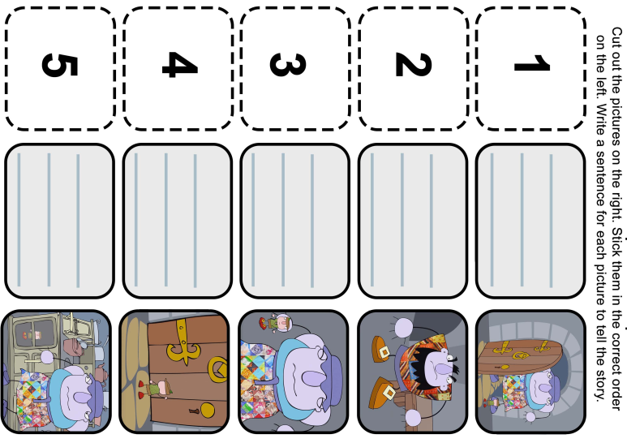

Topic - Geography
Today we are continuing with our new topic, Brazil. 

For this lesson, we will be recapping the 7 continents – don’t worry about writing them down today. Point to them on the screen and tell an adult which continent it is.
We will learn more about the physical and human features found in Brazil and write a little bit about them.

You will need a pen and some paper to complete the activities.

Here is the link to the video for you to watch: https://classroom.thenational.academy/lessons/why-do-people-visit-brazil-60r64r

Mums and Dads – The video is quite long again but can be taught as 2 parts. Here are my suggestions:
First part – Recap past weeks learning up to the physical features of Brazil activity. (10.21)
Second Part – Up to the end to the human features of Brazil activity.

They will need to write 2 sentences for today’s activities:

I would like to visit ___________________ because _______________________. (Physical features)
I would like to visit _________________ in Brazil because ________________________. (Human features)

Children can have a go at writing the whole sentences themselves, filling in the gaps or dictate their sentence to an adult to scribe.

There is also a fun quiz at the end to see how much you can remember!

I hope you have another fantastic day of learning. Do email me if there is anything I can help you with or if you have any questions. I look forward to seeing some more of your amazing learning throughout the day. Don’t forget our catch up zoom session tomorrow at 11.30. You will find out who the Learner of the week is – it could be you!

